Final Year Project Report

**Full Unit – Interim Report**

**A Study in (HCI) Human Computer Interaction**

Riona John

A report submitted in part fulfilment of the degree of

**BSc in Computer Science**

**Supervisor: Zhaohui Luo**



Department of Computer Science

Royal Holloway, University of London

**Declaration**

This report has been prepared on the basis of my own work. Where other published and unpublished source materials have been used, these have been acknowledged.

**Word Count:** 10072 (excluding the appendix)

**Student Name:** Riona John

**Date of Submission:** 22 March 2023

**Signature:**

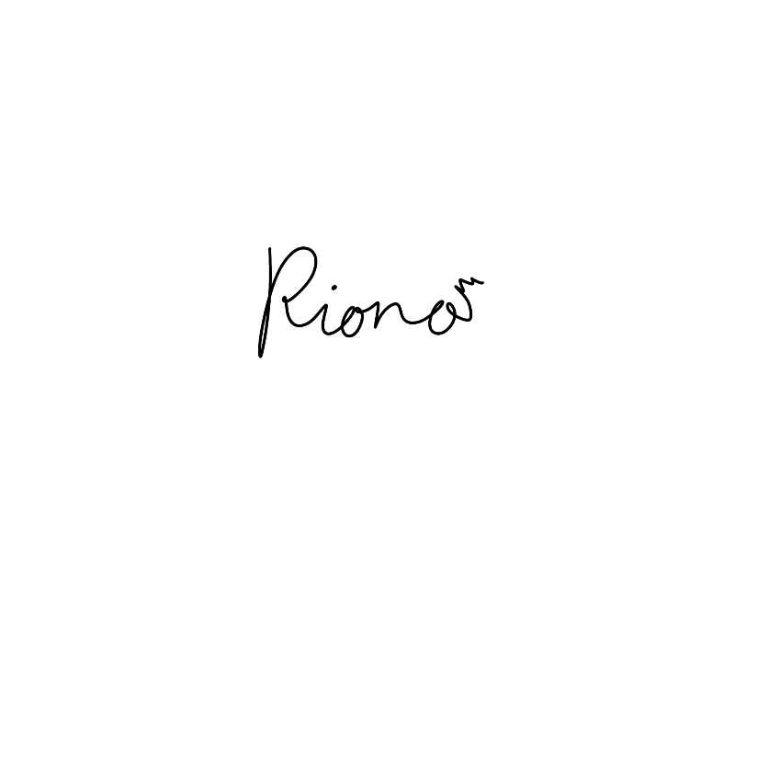

**Table of Contents**

Abstract 4

1. Introduction 5

1.1 Project Specification 5

1.2 Aims & Objectives 5

1.3 Motivations 6

2. Background Theory & Literature Survey 7

2.1 Literature Survey 7

3. Interface Breakdown 9

3.1 Mental Health Online Journal 9

3.2 A Parent-guided shape learning tool for young children 14

3.3 A Personal Portfolio 19

4. Technical Application Achievements 23

5. Software Engineering 24

5.1 Methodology 24

5.2 Code Breakdown 24

6. Demo Video & Evaluation 29

6.1 Demo Video 29

6.2 Evaluation 29

6.3 Testing 30

6.4 Usability Responses 32

6.5 User Manual 36

7. Professional Issues: Universal Usability 37

9. Conclusion 40

10. Bibliography 41

11. Appendix 44

11.1 Project Specification 44

11.2 Installation & User Manual 45

11.3 System Testing 49

11.4 Git Lab Diary (Development Log) 79

# Abstract

My final year project focuses on Human Computer Interaction (HCI), and I am designing three interfaces that show the different aspects of human computer interaction.

Within this report I will further explain and explore what HCI is in my background theory. I will introduce my interfaces by breaking them down and describing the different interactions and the different themes that I have incorporated within my interfaces. I will also show basic wireframes that I created to help me plan my layout and the different placing for my different users. I have also inserted other diagrams, like a site map, as this is important in understanding the flow of the interface, which coincides with the different sections of the interface.

Ensuing, I will be explaining my technical achievements that I learned during this project that I have achieved, as I only originally had a basic concept of the technologies I used. After using these technologies for a while, I better understand the documentation and the different concepts I have used across the interfaces. This leads on to my section on relevant software engineering techniques I used and where I talk about my use of code. I will continue to talk about my demo, evaluation and the different types of testing I used to test my interfaces. Continuing will be an explanation of the professional issue that came up while developing my interfaces, which will lead to my own self-evaluation after concluding this project.

# 1. Introduction

## 1.1 Project Specification

Please find it in the **Appendix**.

## 1.2 Aims & Objectives

I chose this project because I wanted to understand how different types of users interact with an interface and how designers combat certain issues such as universal usability. Additionally, I will spend more time researching how these types of issues can be mitigated against and how I can make similar judgements within my ideas to allow my users to interact with my interfaces fully. Likewise, I will be learning on how to create an interface that can be used intuitively for different types of users. I would also like to be able to create a design that instils familiarity and allows children to add to their working memory that will help them retain their new perception and processing of shapes.

By creating these interfaces, I will gain invaluable skills to develop my portfolio as one of the interfaces I am making.

HCI is quite broad and I only have a limited time to complete these three interfaces, so I will focus on solving issues from the project specification:

Aesthetics

Design

Navigation

Feedback to the user

Cognitive issues (Memory)

Colour blindness as a visually impaired disability

I will ensure that these issues will be fully explored before implementing any onto my interfaces and going through reasonable research to back my mitigations to make the interface as usable as possible. All of my interfaces will be websites that are directed to different target demographics. Therefore, I will try to match many of the visual parts, such as aesthetics, to all genders. Nowadays, certain websites can be more influenced by feminine/masculine and can be targeted to general audience which can still feel less inclusive to everyone. (Abrosimova, 2019) This can take up in the form of the colour themes or even when filling out a form you only get a choice of male and female or even take into account different disabilities. So I will consider these factors and make sure to make it as inclusive as possible. Since one of my ideas will be a parent-guided website but a child learning, the navigation must be simple enough to use so that a child can use their cognitive functions to learn from this website. It is important to note that children’s cognitive functions are still developing so this particular interface will require quite simple navigation/format so that they don’t get overwhelmed. As aforementioned, one of my interfaces, my last one, will be a personal portfolio regarding my past projects. This links well with HCI, in particular looking at design, as I want to explore the different types of presenting information professionally to a user (data visualisation).

## 1.3 Motivations

I have always enjoyed being creative, which is a major part of why I am excited to start and create these interfaces, as it will be a way for me to push the limits of user interaction. Creating interfaces from scratch, from user research to planning wireframes and finally implementing these ideas using my chosen technologies, makes me appreciate every interface I have interacted with; since they all had to go through a similar process for users to have a universal experience. This project will set me up for the future since I want to become a user interface designer. This experience will be invaluable for me to fully understand how much research goes into creating small interactions.

# 2. Background Theory & Literature Survey

Human computer interaction (HCI) combines computer science, cognitive science, and human factors engineering. HCI began to be a popular topic of discussion that appeared in the late 1970s when more people had access to interfaces which affected personal computing (Dix, n.d.). An example of HCI is through a desktop metaphor demonstrated by the apple Macintosh where you would be able to see files and folders as icons that could be dragged and dropped. However, some people use Linux, where you used commands back then. Even though at the time, it seemed odd to move these icons around, this trend has become part of our everyday lives. This is an excellent example of how HCI can make a user find a process more personal and meaningful to them. (Sawyer, 1992)

Considering HCI is a quite widespread topic, there are several ways to measure how effective the interface’s design is, one suggested method is that there could be four design principles: (1) Learnability/Familiarity, (2) Ergonomics/Human Factors, (3) Consistency/Standards, (4) Feedback/Robustness. (Hinze-Hoare, 2004) The four principles cover the full range of System/User/Input/Output Interaction between a user and an interface. I agree that these principles measure HCI well, as humans will process information in a specific way, understand it, and then receive it in a consistent and familiar design throughout an interface to create feedback that can allow the design to grow. In regard to my interfaces these principles in particular can increase/decrease the usability of my interface: (1) the more difficult it is for the user to interact effectively with the interface the less of a chance they would want to use it regularly and gain the familiarity in using that interface. This learning time can be decreased by making use of the user's existing knowledge. I think this is incredibly important for my interfaces as one of them is an interactive learning tool so therefore the familiarity drives the memorability of the learning for the user. (3) Consistency can be broken down to visual, functional, internal and external. (Nikolov, 2017) These sections all make the interface eliminates confusion and increases familiarity in these interfaces.

## 2.1 Literature Survey

Here are a few topics that I researched and looked into before considering my final ideas for my interfaces.

### Gendered Mental Health

Since there is a significant stigma to mental health, especially for teens, that is one of the reasons I wanted to make sure whatever I do to support is accessible to everyone and isn’t intimidating to use because mental health currently is exceedingly gendered. “Most adult studies report that males seek formal mental health services less frequently than females,” this statement tells me that the interface I want to create has to be neutral to attract an equal amount of males and females. (Anita Chandra, August 22, 2005) Something from the report that was fascinating is that they didn’t comment on other people on the gender spectrum, which raised concerns for me, to support the rest of the people on the gender spectrum and how I should best support them. I researched the implications of LGBT people’s mental health to see how they are supported or generally treated regarding their mental health. (McIntosh, 13 Jul 2016.)

### Genderless Design & Inclusive Design

Generally, people from the demographic of adolescence don’t have access to inclusively designed interfaces. So that’s when I wanted to make a safe space through a journal; the colours surrounding the main functionality can be neutral to be relatable to everyone and not try to single out any particular type of group and increase the awareness of genderless design. This report (Cakiroglu, 2017) mentions the presence of a “cyborg manifesto”, which “suggests no gender and no other cultural categorization tools.” Allowing everyone to gain access to this type of design.

### Children’s Cognitive Memory Development (Short Term Memory)

For my second interface, I wanted to explore memory development with children, specifically looking into short-term memory (STM) in children. (Gathercole, 1999) The types are: Phonological, Visuospatial, and Working memory/executive processes. This helped me assess how I wanted the users to learn from my tool. I plan to focus on Visuospatial and working memory as it will be easier to implement images and have access to colours to increase the chance of remembering an object.

I worked backwards from this idea of visual objects to understand what users’ needs to use their working memory well. "Working memory is a limited capacity 'workspace' that maintains information temporarily while it is processed for use in other cognitive tasks, such as reasoning, comprehension and learning". (Usha Goswami, 2007) This tells me that children will require repetition to keep this information in their "working memory".

### Visual Impaired Disabilities within in Children

Regardless, that raised concern for me as I wondered how children with a visual disadvantage could also use my shape learning tool effectively. Regardless, that raised concern for me as I wondered how children with a visual disadvantage could also use my shape learning tool effectively. So the general accommodation I found was colour contrasts, large enough writing, and colour filters. (Beth A. Jones, August 27, 2014) I noticed that some interfaces have a colour blindness filter to focus on the colour that a user can see. I have decided not to do a specific colour filter and make it more general (grayscale filter) as it allows more accessibility to the range of users that can use the tool.

### Pagination vs Continuous Scrolling

A big discussion in the web design community is pagination versus continuous scrolling. Pagination which means having content on multiple pages, whereas continuous scrolling is allowing a user to stay on the same page and move up and down. Continuous scrolling is a favourite feature especially when the screen a user is using on their phone, however in websites, I believe it depends on the situation. Some people suggest that a disadvantage with continuous scrolling is that users, aren’t able to know where they are, leading users feeling “lost and frustrated”. (Julie Campbell, n.d.) In my interface I show both, letting the user to experience the data I present in two different styles.

### Data Visualisation

As I used specific technologies to make my portfolio, I had an easier time determining how I wanted to present my projects and my skills. For example, utilising the components already built into Bootstrap, like cards, gave me the idea to build my type of cards that include a larger font as my project title and a smaller font for the project description. (Anon., n.d.) I used chips similar to tags to show what kind of programming languages I used within my projects, compared to a progress bar or a similar breakdown technique, to better show how I applied those skills in that particular experience.

These ideas really helped to create the interfaces breakdowns which is below.

# 3. Interface Breakdown

## 3.1 Mental Health Online Journal

The first interface is a Mental Health Online Journal. When I was doing research on the outlets of releasing stress/anxiety, I saw a lot of examples of using a diary/journal to create a safe space for an individual. (Cheng, Feb 2015) Based on that research, regarding the range of the target demographic (ages 16 – 25), I created an online journal. Since writing a journal is a well-known outlet that the demographic regularly uses already for general feelings for mental health can help manage anxiety, reduce stress, and cope with depression since it. (L Renee Watson, n.d.) As journals are supposed to be used regularly, this allows me to explore the theme of familiarity.

Journals are supposed to be personal and that is one of the reasons I would like to make this interface very welcoming and private to a user, so they do have a place to keep their private thoughts.

I believe the demographic I am targeting misunderstand mental health since our surroundings have tailored it towards certain genders. I want to address the problem through aesthetics and using all pronouns to show that anyone can use this interface and that mental health can happen to anyone. I explain inclusive design below and how I try to implement different types of aesthetics to combat the stereotypes that come with mental health.

### Inclusive Design

The 7 principles of inclusive design: Flexibly, Simplicity, Consistency, Perception, Equity, Prevention and Accommodation. (Belman-Adams, April 2022) The feature I’m most focusing on is accommodation and equity as I would like all users to feel welcome and feel safe so I tried to avoid using male and female connotations in reference to aesthetic and colours referencing the societal view on “pink is for girls and blue is boys”. I didn’t just focus on gendered aspects but also the different ages I wanted to reach within my target demographic (16-25 year olds). I wanted the overall design to be relatively simple and neutral, the reason I didn’t add pictorial elements in my proof of concept. I was trying to be more aware and understanding if a user is in an emotional state at that time.

### Wireframes

Below are low-fidelity wireframes to show what each web page could look like. These wireframes are a partial set of designs, just a guideline since I would like to build on the inclusivity side of design so that different types of users can say they would feel comfortable using this application.

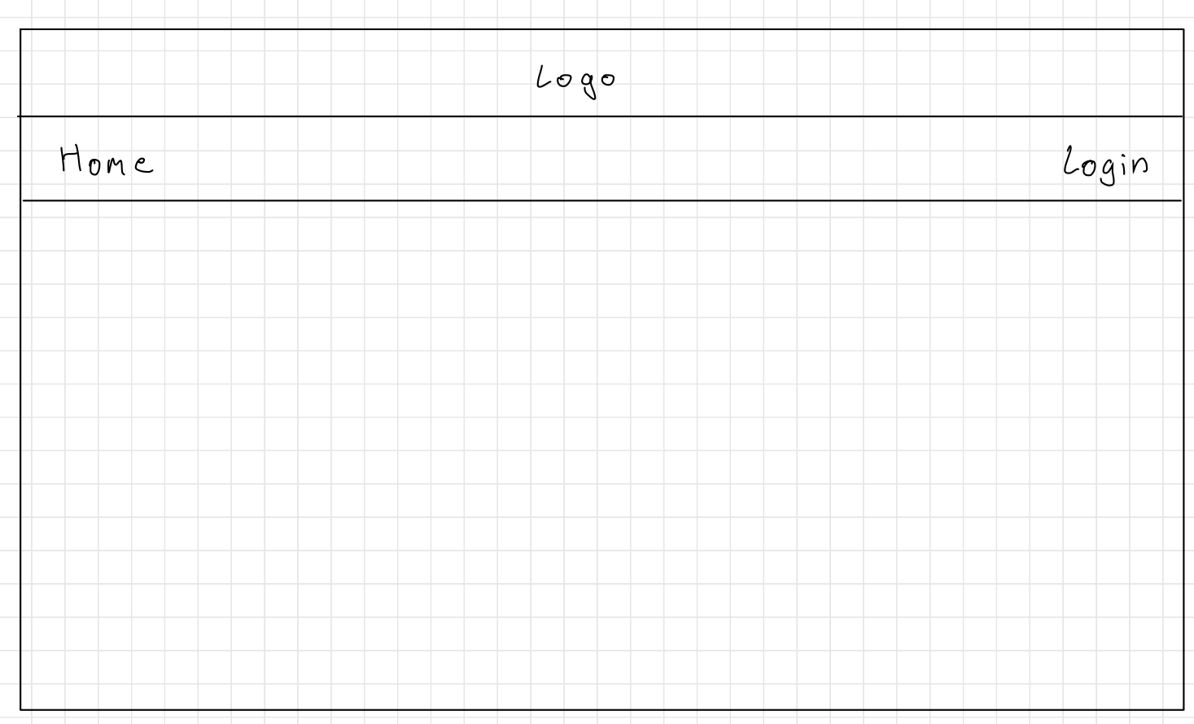

Home Page screen

This will be a link that redirect to this page.

A button that once clicked redirected a user to the login page.

An image or logo that I make myself

Figure 1: Home Page (User has not Logged In yet)

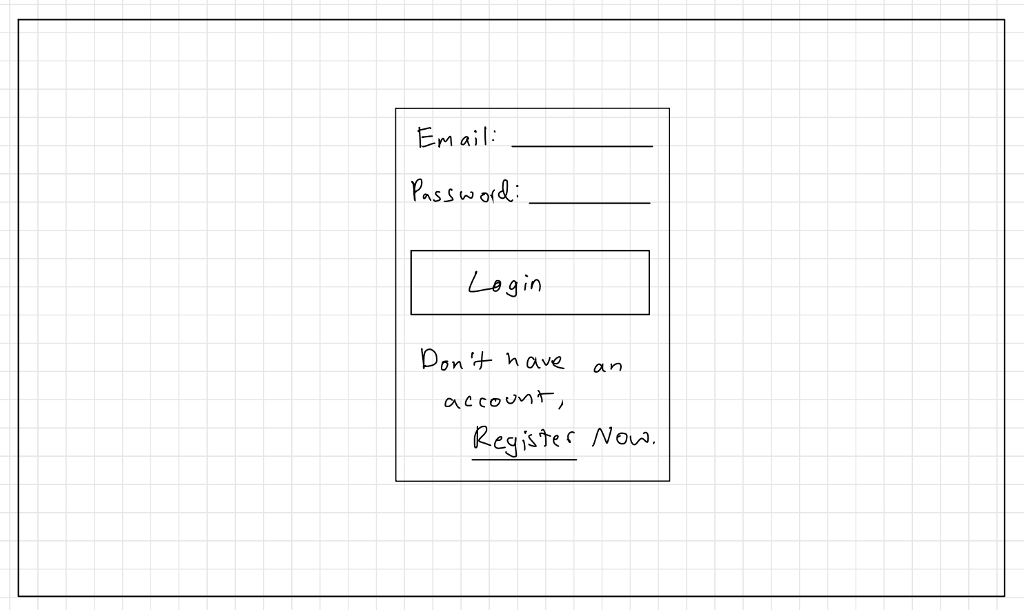

Login Page

Figure 2: Login Screen

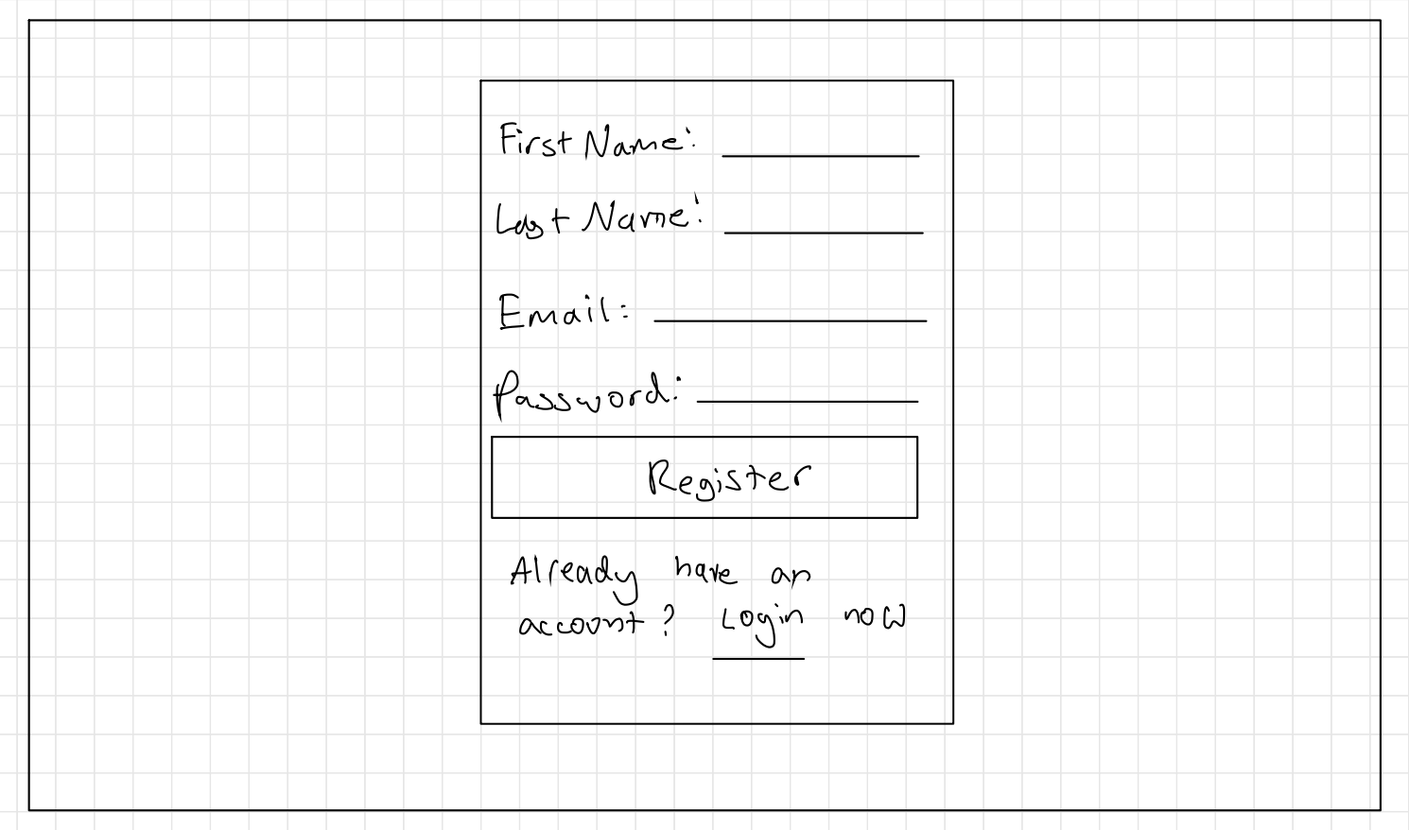

Register Page

Figure 3: Register Screen

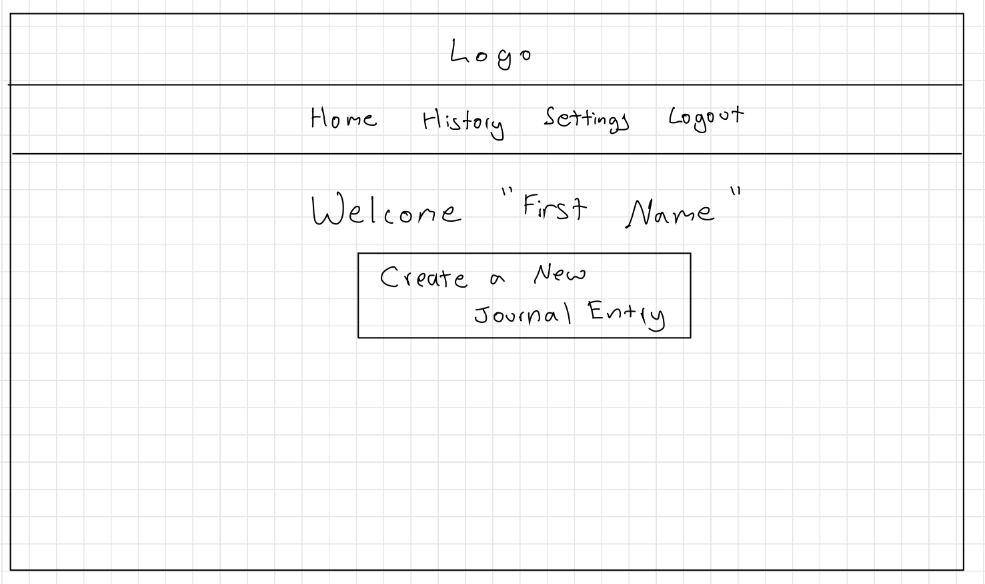

From Register Information

Journal Home Page

Figure 4: Journal Home Page (User Logged In)

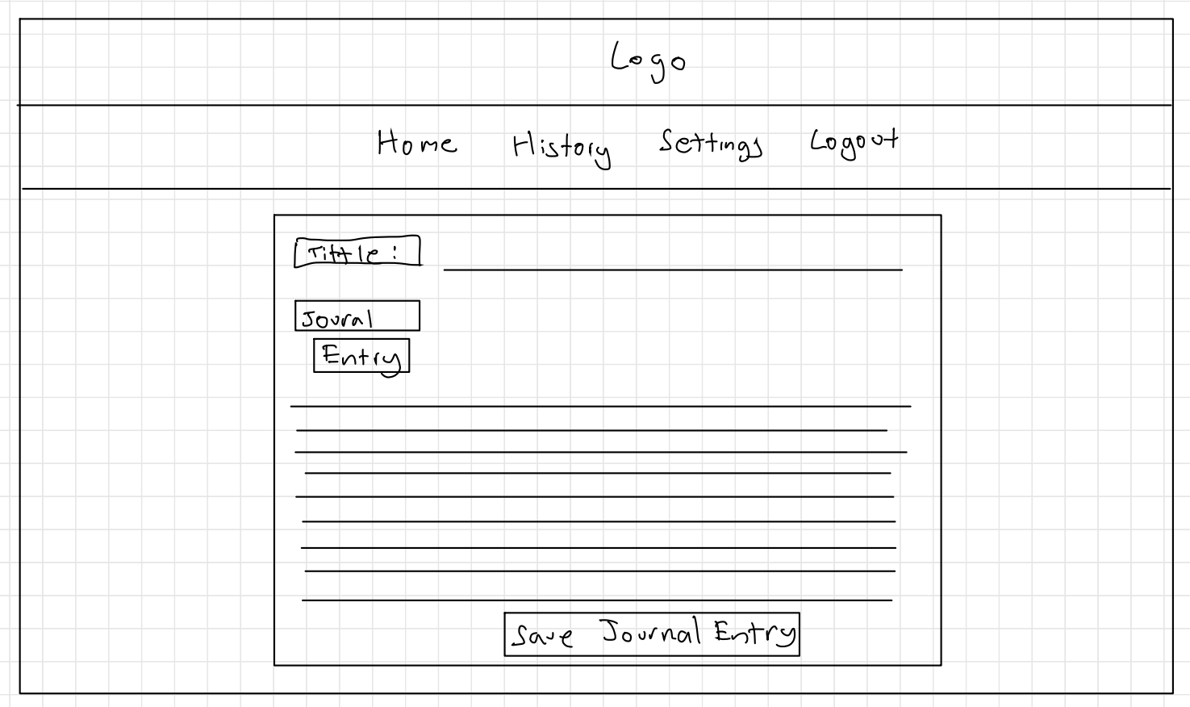

New Journal Entry Page

Figure 5: User creating a Journal Entry

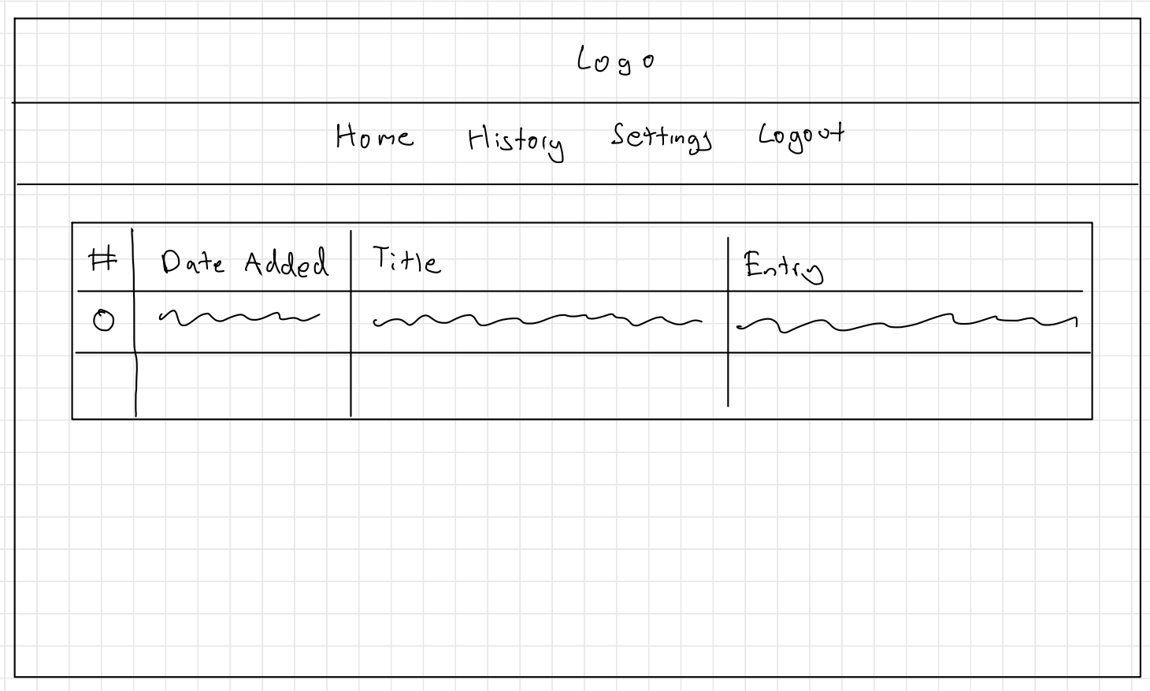

Journal History Page

Figure 6: User can see their previous journal entries

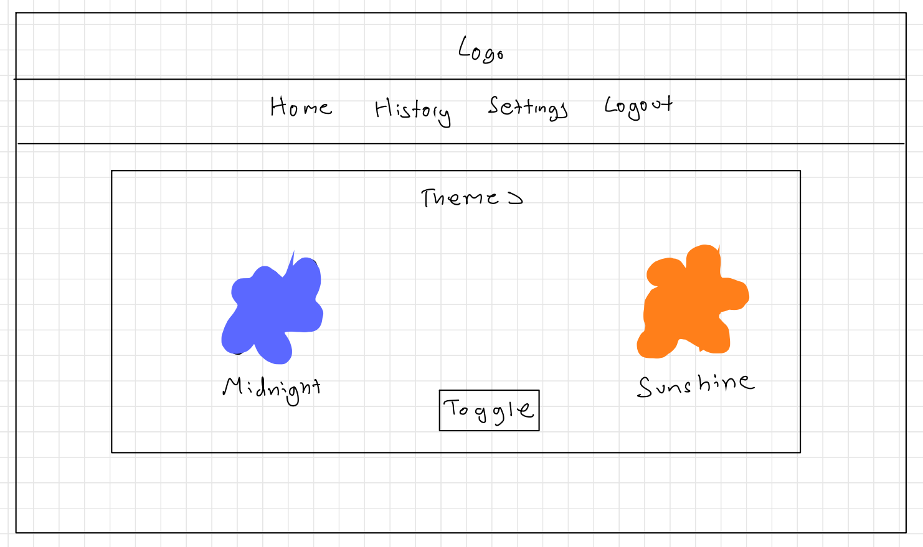

Settings Page

Figure 7: User can change themes on the settings page.

### Site Map

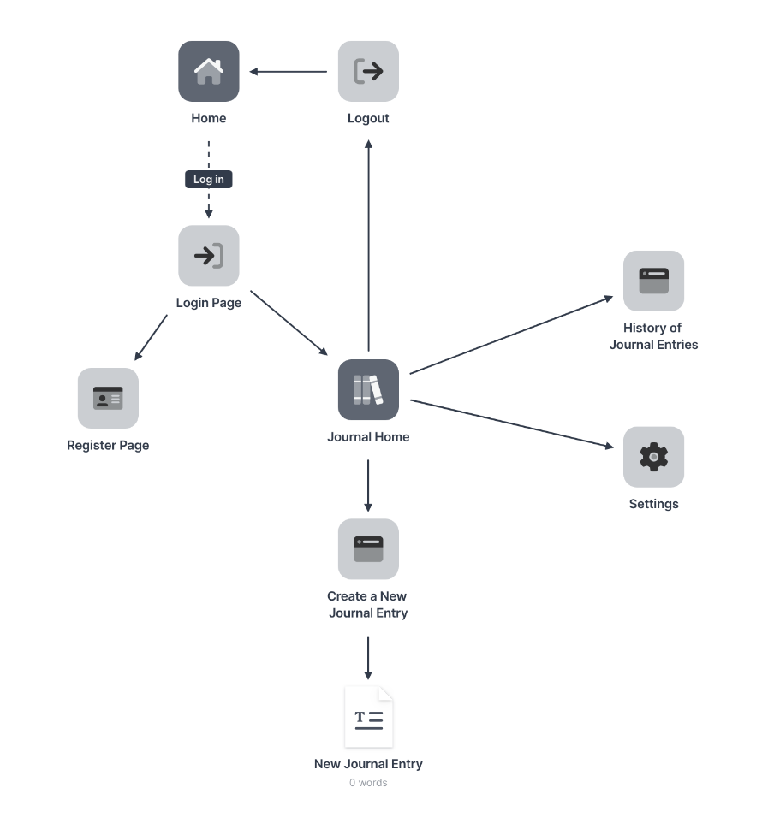

Figure 8: Mental Health Online Journal Site Map

### Design & Interaction Features

### Home Page

Home Page has a navbar that has a home link and a button that directs the user to the login page.

### Help Page

This is supposed to be a support page, where users would be able to go seek external support from this website.

### Login Page

A user will enter their email and password and it will authenticated by the firebase authentication process which will then redirect theme to the journal home page.

### Register Page

A user can easily register by just adding their first name, last name, email and their password to the system through a form which will then automatically sign them in and direct hem to the journal home.

### Navigation Component

I created two navigation components as one is for just a view interaction in the initial home screen and the other navigation bar once logged in has more private actions, like creating a journal entry. The journal home navigation bar includes history, settings and the log out button.

### Create Journal Entry

Once you sign in, you are presented with a container with your first name to add to the customised experience. You will also see a button that will re-direct the user to a journal entry page. It has title text box and an entry text box. Once the user decides they are finished writing their entry, they have the option to save it and then they get directed to the history page to see their past journal entries.

### History of Journal Entries Page

This shows the user all the entries they have written and saved to the database.

### Settings Page

This where a user can change the theme of the website to a customised dark mode called midnight to a light mode that’s also been customised to the colour palette of yellow (as explained before as an inclusive design colour).

## 3.2 A Parent-guided shape learning tool for young children

The second interface is a Shape Learning Tool. I am making this tool parent-guided, as I chose to make a website instead of an app so I tried to factor if the target demographic (18 months – 3 years old+) (Academy, 2017) might struggle to click on the website or interact with it. The reason I didn’t use an app was because I was afraid I wouldn’t be able to pick up the technologies as fast and easily, especially since it didn’t seem feasible with the amount of the time we had.

The reason I picked shapes as the topic to learn is because it sets up children to understand math, sort and categorise, learn letters and numbers, use descriptive vocabulary, use visual discrimination. (BabySparks, 2019) I didn’t just want to make a learning website, I wanted to address an issue or disability and that is why I picked colour-blindness which I try to solve by a grayscale filter, this is explained below.

### Cognitive (Memory) Development

When I researched the topics which are most effective for long-term development, shapes and numbers were the two key topics I encountered. The reason I chose shapes was because I also wanted to explore colour blindness and its effect on memory learning. Since colours and shapes are very common observable traits to young children, they are part of the foundation for higher-level concepts like counting numbers and recognising letters. (Intervention, n.d.)

### Colour blindness affecting design on websites

Colour blind users need to be able to see a different change in state when clicking/hovering on a button on a website to identify an action occurring, e.g. that state being highlighted in a bright contrast colour or underlined. Regarding my shape learning tool, that is one of the reasons I am using a colour blind filter that would turn the image grayscale, and I would already have patterns on the shapes so that users can identify the shapes that way too. (Bigman, 2012)

### Wireframes

Below are low-fidelity wireframes to show what each potential web page could look like. These wireframes are a partial set of designs, just a guideline since I would like to build on improving on subtle hints that would be able to help a general visually disabled user so that colour blind users aren’t the only users that can benefit from this tool.

Home Page

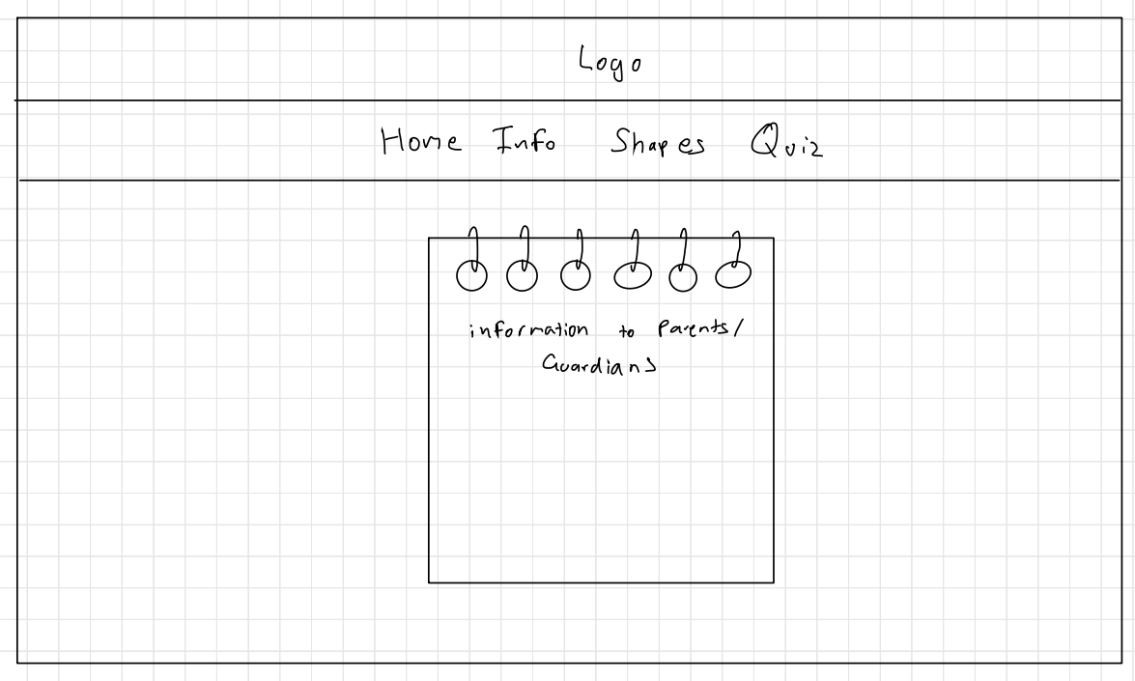

Figure 9: Shape Learning Tool Home Page

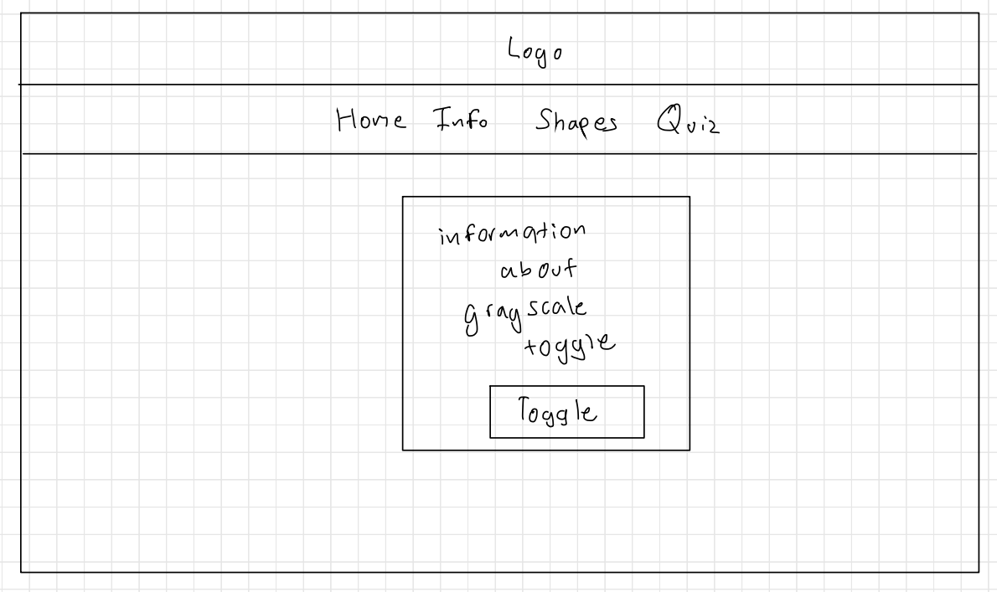

This button will make relevant images grayscale to help colour blind people focus on the shape pattern rather the colour.

Information Page

Figure 10: Information Guide Page (where colour blind users can use a grayscale mode)

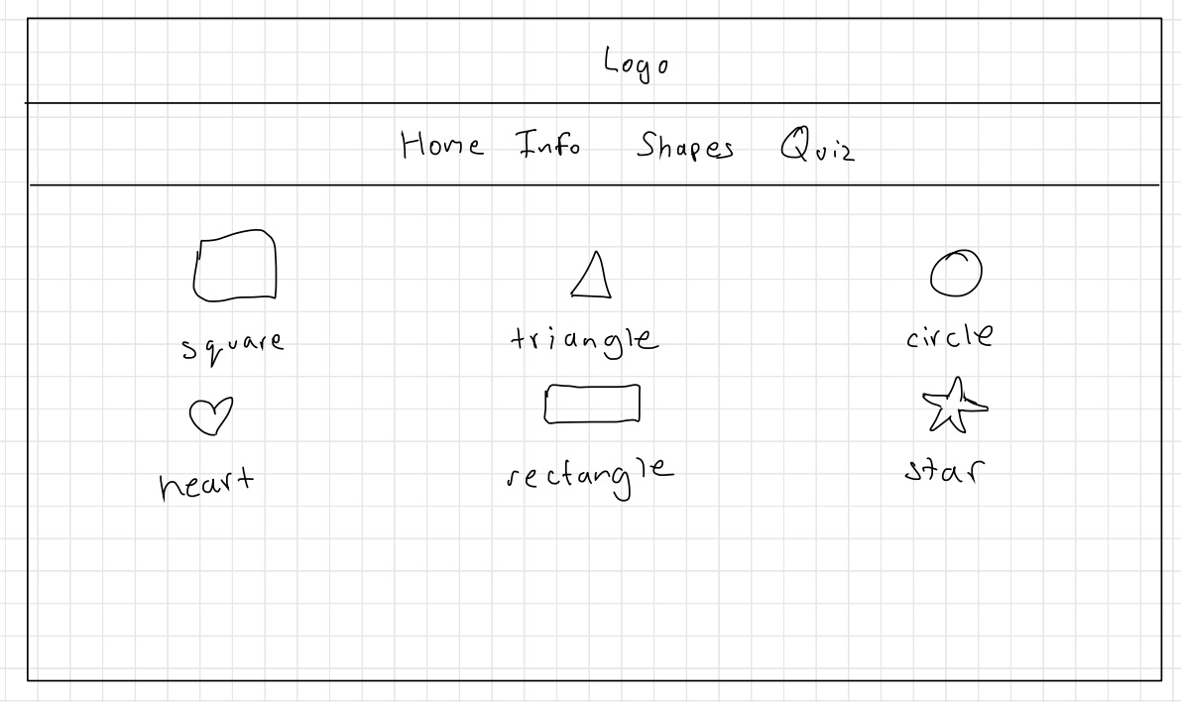

A user can click on the shape name to access the individual page for that shape page. (Shapes will have patterns as another way for users to recognise what that shape is)

Shapes Page

Figure 11: Shapes Page

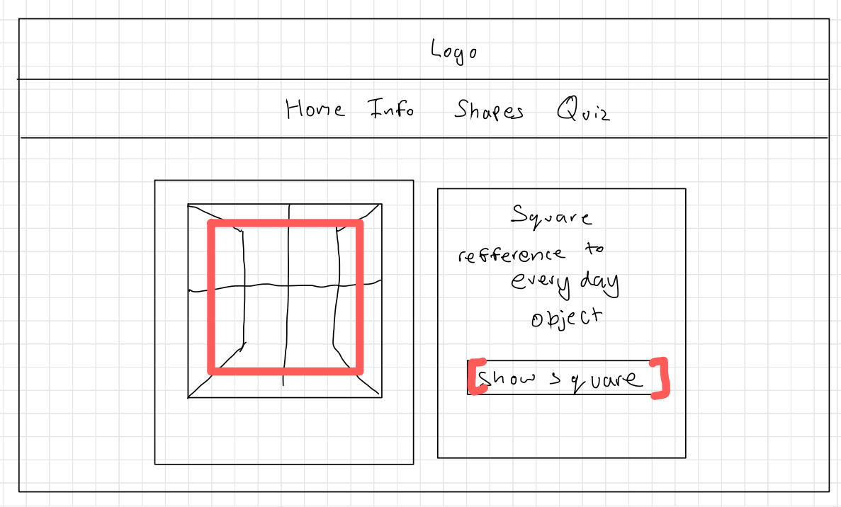

When the user presses the button, the shape that can be seen in the image and is highlighted with colour or/and pattern.

Example Shape Page

Figure 12: An example of what an individual shape page would look like

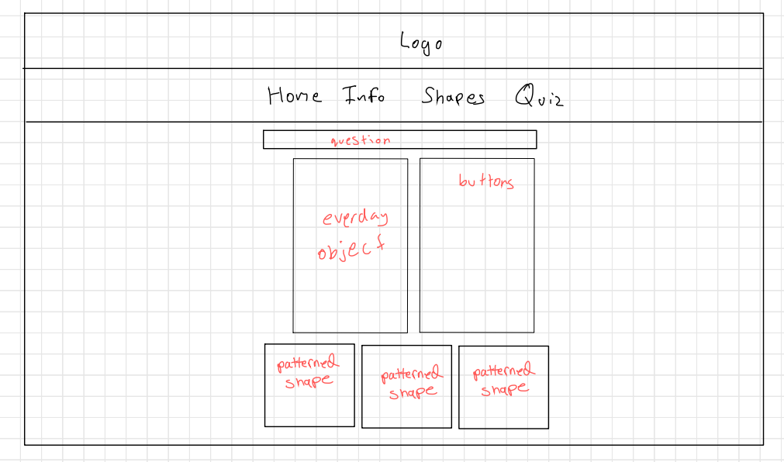

Multiple choice quiz, 6 questions as it goes in order of the shapes. It currently just shows if a user gets it correct/wrong, and then user will need to manually need to click on “next question” to move on.

Quiz Page

Figure 13: Quiz Page

### Site Map

Figure 14: Parent-Guided Shape Learning Tool Site Map

### Design & Interaction Features

### Home Page

This page is currently informing to the parent (user) that this website is a tool to help children learn shapes.

### Info Page

This is where parents are directed from the home page to be able to toggle the “colour blind switch” which should make all relevant images grayscale on the website. Currently can only make the grayscale feature work on the Info Page and not accessible on the other pages.

### Shapes Page

The shapes page is a menu of all the shapes I provide for a child to learn on this website. I created six shapes because I wanted to have enough to test to ensure that the child is learning and should be able to make minimal familiarity with the shapes and their respective colours/patterns I have chosen.

### Example Shape Format page – “Square Shape Page”

Each of the shape pages have an everyday object as an image on the left and a small description asking the user if they can recognise the shape outline, if not there is also button below that description that will make the image highlight the shape.

The reason I used everyday objects to show different shapes is that, I was hoping that when the children aren’t using the website, in their everyday life their brains will make subtle connections, e.g. a window is normally in the shape of a square so the children will then be used to that idea. Another way I want to create familiarity is if the shape has a similar pattern, e.g. a square uses a checked pattern which are like small squares to create a similar connection.

### Quiz Page

Similar to my wireframe in Figure 13, there is an information box above the everyday object and button menu, explaining to the user that this is a place to test your memory of the different shapes. I use the same everyday objects allowing the user to be already familiar with the objects. User should be able to remember the associated shape and select one and then be able to check if they are right. Then use the “next question” button to iterate through the rest of the questions.

## 3.3 A Personal Portfolio

As one of the goals within my final year is to grow myself, I choose to create a personal portfolio for my third interface, as it is a passion project that I have been meaning to take up and also would make my interview process a lot easier when applying to jobs. The main reason a portfolio is helpful for an employer, is to see a potential employee’s skills, past projects and general skills they bring to the company, this means my target audience is either a recruiter or potential company that would like to hire me.

### Importance of the electronic portfolio

We were asked to describe how this project will help my future career. One of the ways this project has helped me is to showcase all my skills and experiences so far to create a portfolio. I want to go into user experience and user interaction. Something I have found necessary while applying to graduate schemes is that many companies would like many of their future employees to have a portfolio to see their experience and give them a competitive edge. This is great example that will help me prepare myself for the workplace and making sure I maintain my portfolio in present time. (Wilson, 2018)

### Wireframes

Below are low-fidelity wireframes to show what each web page could look like. These wireframes are a partial set of designs, just a guideline since I would like to build on the professionalism of data visualisation so that I can reach my target audience in the best possible way.

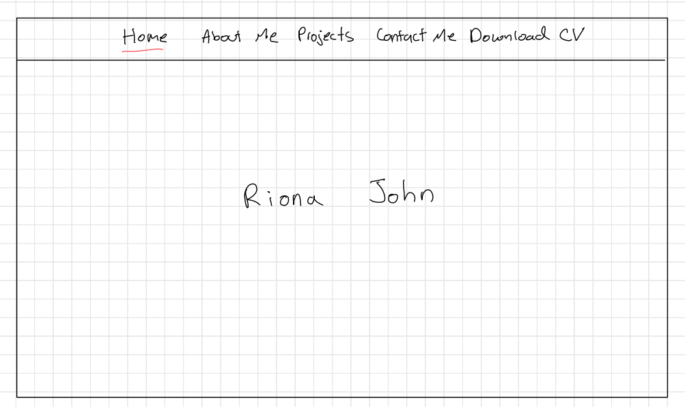

Figure 15: Home Page

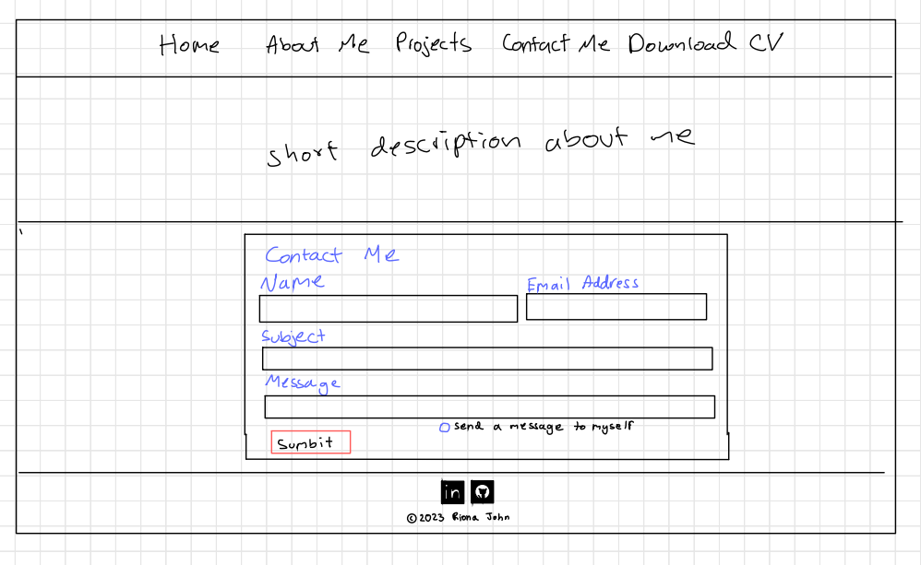

For the sake of simplicity, the contact form is currently purely an aesthetic. I created it to show a type of interaction rather than for it to be a working functionality.

Footer: includes icons that redirect the user to my LinkedIn and GitHub.

Figure 16: About Me Container and my Contact Form

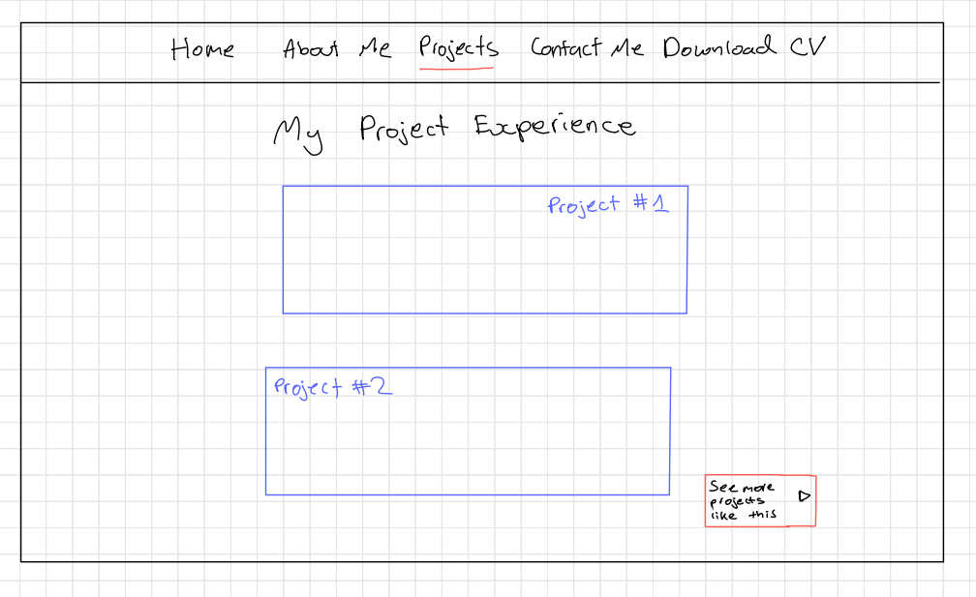

This how I choose to showcase my most recent or favourite projects. The button will allow users to see more projects that I have done in the past.

Figure 17: Projects Page

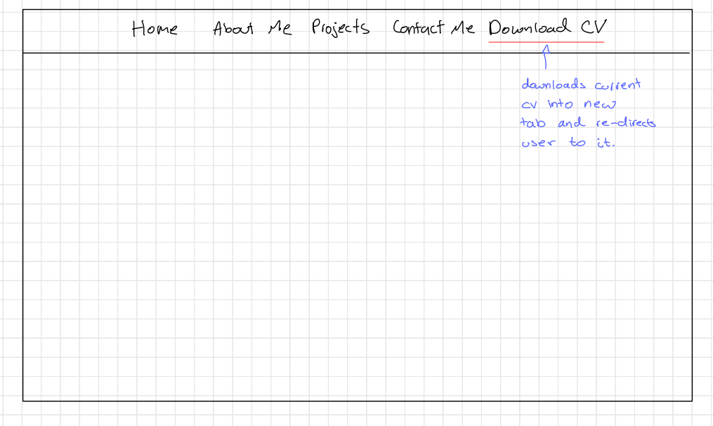

Downloads current CV into new tab and re-directs the user to it.

Figure 18: Downloads CV (new tab opens)

### Site Map

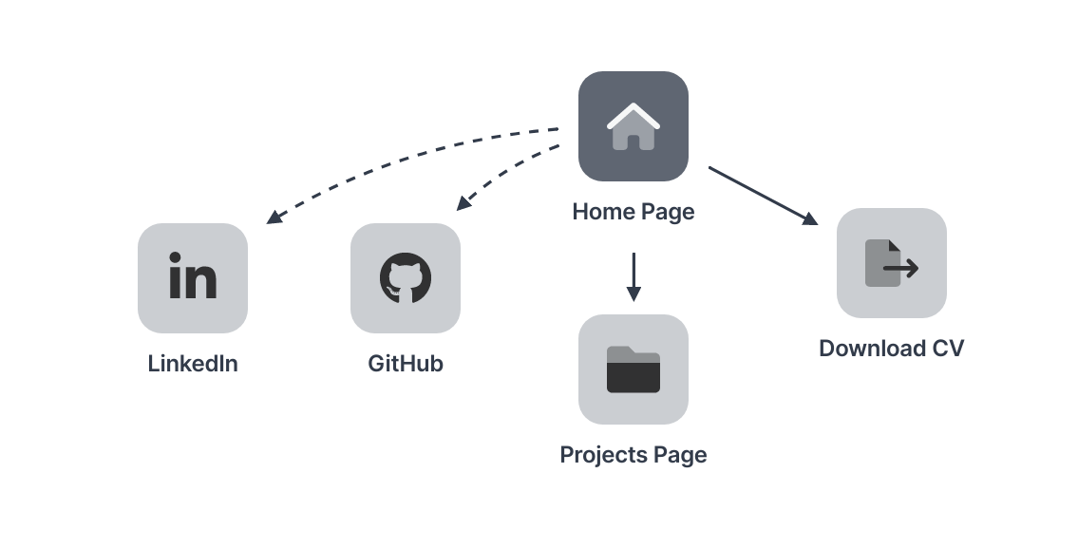

Figure 19: A Personal Portfolio Site Map

### Design & Interaction Features

### Home Page - Navigation Bar

This page consist of my name as the first object a user can see, users will be able to scroll to see my about me container and the contact form. The containers I mentioned above also have reference links to them on the navbar, so that anytime a user wants to go back to that container it will direct the user to that part of the container. As previously mentioned, I included pages by also allowing my CV to be download within a link on the navbar. That will open a new tab and re-direct a user to that asset.

### Footer

This is a component I didn’t build in my other interfaces as they didn’t necessarily require them, also a footer is a well know are to find extra contact information such as my LinkedIn and my GitHub as seen as icons.

### About Me Container

A container that was filled with a short description of myself and what my portfolio is about.

### Contact Form Container

A container, where users could fill out the form to be able to send me requests, currently the functionality isn’t there, so I have focused on the user intention and interaction of using this form.

### Projects Page - Showcase Container

Once a user clicks on Projects as a nav link, they are redirected to a container where it is shows two of my most proud projects, it has an additional button to allow a user to see more projects.

# 4. Technical Application Achievements

### React

In my application, I generally use Hooks to change my variable’s value using these methods: useState() and useEffect(). UseState is a Hook that allows you to define a variable that is a current state and also a method that can update the current state. UseEffect allows me to add extra methods to the original function while effecting the original function.

### Bootstrap & React – Bootstrap

React Bootstrap is a form of Bootstrap that is more compatible with React.

Certain components in my interfaces have prebuilt class structures, e.g. “navbar” is a class that bootstrap provides that creates a navigation bar that is presented on the web page. This node module also has the main css file that is imported into my pages to interact with my components that I create as it creates base css for the class structures I use.

React – Bootstrap is a library of convenience as I prefer to use certain components that already have built in css and base structure, this helps me have an initial design that I can add on to easily rather than building the css e.g. buttons.

### CSS

For my 1st interface, I have made 2 different themes which will be covered in Inclusive design. Currently they don’t work interchangeably however this functionality will be worked on over Christmas break.

### Node.js & Node Package Manager (NPM)

Node.js is a framework that can run JavaScript code on your machine while npm is a package manager. Using npm we can install and remove Javascript packages also known as node modules. (ALAVALA, n.d.)

### React interacting with Firebase

For my 1st interface I use Firebase to store my data, in doing so it means I have to create a firebase configuration file that has all the methods I require as well as my links and ids to the different types of databases I use. For example, databaseURL: https://mental-health-online-journal-default-rtdb.firebaseio.com is the connection URL for my real-time database.

### Firebase

For my first interface, authentication is needed, so I use the authentication service to authenticate by email and a password. This stores the different created users, their created account date, and their user ID. Firebase generates unique password hash parameters for each project, therefore allowing a user to feel secure when using the tool.

I use the Cloud Firestore Database to also store the authenticated users in a database which stores their personal information such as their first name and last name and which authProvider they used to create the account.

I use the Real-time Database to store my user’s personal journal entries under their personal user id. Each of these journal entries will have their own id as well. I reference this database to show the journal entries in a table as well, so that the users have access to their previously written entries.

# 5. Software Engineering

In this section I will be describing how I used different software engineering tools. I will also be exploring my code from my first interface.

## 5.1 Methodology

### 5.1.1 GitLab – using Git

When I first started my project, I made sure to only work in specific branches relevant to my interfaces; mental-health-online-journal, shape-learning-tool, personal-portfolio. This made me conform to certain standards and also allowed me to spend enough time on each different interface. Since my process to start an interface was to create a blank React project. After that plan the wireframes to show me the general composition of how each element will look like on the website.

## 5.2 Code Breakdown

Within my code and my different interface project directories, I have added Java documentation and additional comments where necessary to explain my code, as seen below

### 5.2.1 Mental Health Online Journal

### 5.2.1.1 Journal History component

|  |
| --- |
| //Reference: https://www.youtube.com/watch?v=NueuZjC9_Og  //Creator: The Amazing Codeverse  import React, { useEffect, useState } from 'react';  import { ref, onValue } from "firebase/database";  import { useAuthState } from "react-firebase-hooks/auth";  import { auth, journalEntryDatabase } from "../firebaseConfig/firebase";  import { Table } from "react-bootstrap";  import 'bootstrap/dist/css/bootstrap.min.css';  /**   * JournalHistoryTable is referencing the firebase real-time database to get a user's individual journal entries.   *   * @returns a table of previous journal entries   */  export function JournalHistoryTable() {    const [tableData, setTableData] = useState([]);    const [user] = useAuthState(auth); //current user logged in    const [currentTheme, setTheme] = useState(      localStorage.getItem('currentTheme') || ''    );    useEffect(() => {      localStorage.setItem('currentTheme', currentTheme);      //localStorage requires the page to store the currentTheme as a variable that will help other pages in the website to follow the correct css style.      setTheme(currentTheme);      document.body.className = currentTheme;    }, [currentTheme]);    useEffect(() => {      try {        const journalRef = ref(journalEntryDatabase, "/journalEntries/" + user?.uid);        /*this is referencing the firebase real-time database where it stores user’ journal entries */        onValue(journalRef, (snapshot) => {          let entryRecords = [];          snapshot.forEach(childSnapshot => {            /**the reason it is checking for a childSnapshot is because the reference             * only isolates the current user’s journal but not the individual entries**/            let keyRecord = childSnapshot.key;            let data = childSnapshot.val();            entryRecords.push({ "key": keyRecord, "data": data });            /**individual entries being added to an array so that             * can be set to the table’s contents**/          });          setTableData(entryRecords);        });      } catch (error) {        alert("No entries saved!");      }    }, [user]);    /**dependent on the current user    (refreshes the results if a different user is logged in)**/    return (      <>        <Table bordered className='historyTable'>          {/* displaying the results of my query */}          <thead>            <tr>              <th>#</th>              <th>Date Added</th>              <th>Title</th>              <th>Entry</th>            </tr>          </thead>          <tbody>            {tableData.map((row, index) => {              /**it goes through the values of the entries,               * and takes specific parameters and return it to the user**/              return (                <tr>                  <td>{index}</td>                  <td>{row.data.currentDate}</td>                  <td>{row.data.title}</td>                  <td>{row.data.entry}</td>                </tr>              )            })}          </tbody>        </Table>      </>    )  } |

### 5.1.1.2 Toggle Theme (Midnight and Morning Sunshine)

|  |
| --- |
| import React, { useState, useEffect } from 'react';  import 'bootstrap/dist/css/bootstrap.min.css';  import '../css/OverallCSS.css';  import defaultTheme from '../graphics/default-theme-resize.png';  import sunshineTheme from '../graphics/morning-sunshine-resize.png';  /**   * Settings Container gives a user a choice to change themes.   *   * @returns Container showing the two themes and a toggle button.   */  const SettingsContainer = () => {      const [currentTheme, setTheme] = useState(          localStorage.getItem('currentTheme') || ''      );      useEffect(() => {          localStorage.setItem('currentTheme', currentTheme);         /* localStorage requires the page to store the currentTheme as a variable that will help other pages in the website to follow the correct css style.*/          document.body.className = currentTheme;      }, [currentTheme]);      function toggleThemes() {          if (currentTheme === "") { /*midnight being the default theme*/              setTheme("sunshine-theme");          } else {              setTheme("");          }      }      return (          <>              <br />              <div class="container">                  <div class="row">                      <div class="col">                          <h2>Themes</h2>                      </div>                  </div>                  <div class="row">                      <div class="col">                          <img                              src={defaultTheme}                              alt="Default"                          />                      </div>                      <div class="col">                          <img                              src={sunshineTheme}                              alt="morning-sunshine"                          />                      </div>                  </div>                  <div class="row">                      <div class="col">                          <h1>Midnight</h1>                      </div>                      <div class="col">                          <h1>Morning Sunshine</h1>                      </div>                  </div>                  <div class="row">                      <div class="col">                          <button class="btn-toggle" onClick={toggleThemes}>Toggle Themes</button>                      </div>                  </div>              </div>          </>      )  }  export default SettingsContainer |

# 6. Demo Video & Evaluation

## 6.1 Demo Video

Below is a link to a demo of my proof of concepts so far:

**YouTube link:** [**https://youtu.be/l0wZDmtLEgg**](https://youtu.be/l0wZDmtLEgg)

## 6.2 Evaluation

### 6.2.1 Mental Health Online Journal

Previously in my aim and objectives I mentioned that the issues I would like to solve are aesthetics, design, navigation, feedback to the user.

By finishing this interface, I believe I have tackled aesthetics by adding and have the accessibility to the themes so that users have the choice to change how they want to interact visually with the interface.

The navigation bar, I have created fits well with consistency or and standards within measuring how effective the interface’s design is. (Hinze-Hoare, 2004) Since the nav-bar is fixed is deigned horizontally which is a common practise for websites. I don’t have too many instances where the user would require feedback from the interface, therefore the main effect that I have included are alerts that make the user aware if they have saved their journal entry for example.

### 6.2.2 A Parent-guided shape learning tool

For my shape learning tool, I address cognitive issues (memory) and colour blindness as a visually impaired disability specifically to the target demographic of young children (18 months – 3 years old+).

I am trying to support children who have any visually impaired disability by allowing them to have a grayscale filter available to change relevant shape images with a grayscale filter on. The grayscale will enable children to focus more on the shape and the pattern on the shape. Instead of focusing on the colour, with the help of specific colours and bright contrast colours, it increases their chance to identify the shapes and allows neurotypical children to access the colours.

Learnability or and familiarity design is used - for example all the shapes pages have the same structure as there is an everyday object that looks similar to the shape, and a parent can interact and have a button to show the image overlaid on the object. (Hinze-Hoare, 2004) Therefore these objects would be engrained into the young minds and so should allow them to start being familiarised with the shape if they saw a similar version of the object they were introduced to.

### 6.2.3 A Personal Portfolio

Since this interface also showcases my previous projects, it was important for me to show a more professional style to this interface. For example, my navigation in my other interfaces were also above the webpage and in a highlighted colour of black to contrast to the amount of colour in the webpage. However in this interface, the navigation has been blended into the background, and isn’t highlighted but rather for the user to see it as an afterthought while scrolling down my page. All my pages have a common theme of purple and red as my main background image is based off those two colours.

The main purpose of this interface is to understand how a user can benefit from a professional design and how do they understand all the information displayed to them. Something that I made sure to implement was a consistent standard, as that is a guaranteed way of making the website look professional. Many standards include: using whitespace (padding in text boxes to highlight text), creating contrast (different tones of red and purple contrast while staying on theme), maintain size/scale (I maintained my style for headers and body text), label clearly (a feature HCI focuses on as feedback to user, as it clearly stating what each button will provide back to the user). (Strantz, 2021)

## 6.3 Testing

### 6.3.1 Traditional System Testing Table

I have done system testing within the **Appendix**. On completing my interfaces, I will be referring to both my system testing as well as usability testing for all my interfaces. I prefer this process to TDD (Test Driven Development) and Unit Testing because I think it shows a more reliable representation of how the user is interacting with the system rather than just presenting that the system works. Especially since my area of study isn’t concerned with the functionality of my interfaces but rather the interaction between the user and the proposed interfaces.

I also used a test library called cypress, but while conducting tests, it failed to show certain key components like validation in the form of popups, I have left some example files within my first interface with the folder “cypress/e2e”. However as mentioned before my main source of testing will be seen in the Appendix.

### 6.3.2 Testing Usability

Since I’m exploring the study of HCI, I wanted to consider how to test the usability of each of the interfaces I make. The way I choose to test usability of my interfaces is using Nielsen’s heuristic principles, by creating a questionnaire for users to write how effective the 10 principles below were shown in my interface. (A.A. Istri Ita Paramitha, 2018) The explanations are sourced from (Aela, 2022):

1. **Visibility of system status (feedback)** - keeping users informed about their actions and what’s happening at a given interaction.
2. **Match between system and the real world** - avoiding marketing jargon or other expressions that might be familiar to who is building the product but not to their audience
3. **Use Control and Freedom** - give users the freedom to decide and take the actions they see fit — except for rules that go against the system or interfere with some functionality.
4. **Consistency and Standards** - an interface must follow the system’s conventions, maintaining interaction patterns across different contexts.
5. **Error Prevention** - prevent problems from occurring.
6. **Recognition Rather than Recall** - to make options and actionable components visible; this is important because it’s easier for us to recognize something rather than remember it.
7. **Flexibility and Efficient of Use** - enabling personalization by tailoring content and functionality for individual users.
8. **Aesthetic and Minimalist Design** - create interactions that contain only essential information.
9. **Help users recognize, dialogue, and recovers from errors** - express error messages in plain language: code-free and clear.
10. **Help and Documentation** - concerns documentation that will help users understand how to perform their tasks.

**Template:**

|  |  |
| --- | --- |
| **Interface Number:** | |
| **For the following standards, please give an explanation, where possible, if not applicable (*please write N/A*):** | |
| **1. Visibility of system status (feedback)** |  |
| **2. Match between system and the real world** |  |
| **3. Use Control and Freedom** |  |
| **4. Consistency and Standards** |  |
| **5. Error Prevention** |  |
| **6. Recognition Rather than Recall** |  |
| **7. Flexibility and Efficient of Use** |  |
| **8. Aesthetic and Minimalist Design** |  |
| **9. Help users recognize, dialogue, and recovers from errors** |  |
| **10. Help and Documentation** |  |
| **Extra Feedback:** |  |

You can find the responses in the **Usability Responses****.**

Another way to determine usability is doing a Post-Study System Usability Questionnaire (PSSUQ) which is a 16-item standardized questionnaire. It is widely used to measure users’ perceived satisfaction of a website, software, system or product at the end of a study. (UIUXTrend, n.d.)

For the sake of simplicity I will be using the online PSSUQ calculator to show different responses of my interfaces. **Source: (**[**https://uiuxtrend.com/pssuq-calculator/**](https://uiuxtrend.com/pssuq-calculator/)**)**

**Template:**

|  |  |
| --- | --- |
| **Interface Number:** |  |
| **Overall PSSUQ Score** |  |
| **System Usefulness (SYSUSE) Score** |  |
| **Information Quality (INFOQUAL) Score** |  |
| **Interface Quality (INTERQUAL) Score** |  |

The lower the scores, the better the performance and the higher the perceived satisfaction.

You can find the responses in the **Usability Responses****.**

The reason I am using two different usability questionnaires is because with the questionnaire that uses Nielsen’s heuristics will have more specific and detailed feedback so that I can understand what users could do within in my completed interfaces, however the PSSUQ questionnaire is a standardized template that will give me a score to show how usable my interface is under categories.

## 6.4 Usability Responses

Here are the responses I collected from my peers:

### 6.4.1 Nielsen’s Heuristic Principles Questionnaire

**Responses:**

|  |  |
| --- | --- |
| **Interface Number:** 1 (Mental Health Online Journal) | |
| **For the following standards, please give an explanation, where possible, if not applicable (*please write N/A*):** | |
| **1. Visibility of system status (feedback)** | All interactions are appropriately labelled. There are no interactions that are missing labels. |
| **2. Match between system and the real world** | There is an option to create a new Journal entry with a title, description and date. This is similar to how diaries may be structured in a real-life journal. |
| **3. Use Control and Freedom** | The user has the freedom to add as many journal entries as they want. Additionally, they can also customise the interface by toggling between two different themes. They can also view the diary entries after they have created them. |
| **4. Consistency and Standards** | The website has a favicon which is an industry standard when making sites and websites. Additionally, the website utilises a login system that a user is familiar with seeing, and uses vernacular that a user will also be used to, such as “settings” and “home”. |
| **5. Error Prevention** | I did not encounter any errors. However, when logging in with invalid credentials I was assured that those details were not present in the system. |
| **6. Recognition Rather than Recall** | N/A |
| **7. Flexibility and Efficiency of Use** | The user-flow is simple and understandable. |
| **8. Aesthetic and Minimalist Design** | The interface has a minimalistic design. Personally, I would appreciate better use of space and a more engaging display, but the interface presents all necessary components appropriately. |
| **9. Help users recognize, dialogue, and recovers from errors** | N/A |
| **10. Help and Documentation** | The help page – at the time of writing – is available only on the homepage, but I am not able to access it whilst logged in to the system, which I find to be quite defunct, as in order to find help – I can only access the help page that is out of the system. I would suggest adding this page to the login area or having it in the footer of the page.  Additionally, the help page does not actually have help about the system on it, but instead redirects to helpful mental health resources. |
| **Extra Feedback:** |  |

|  |  |
| --- | --- |
| **Interface Number:** 2 (A Parent-guided shape learning tool for young children) | |
| **For the following standards, please give an explanation, where possible, if not applicable (*please write N/A*):** | |
| **1. Visibility of system status (feedback)** | Clear Alert boxes as to whether the user has answered the question correctly. |
| **2. Match between system and the real world** | The system is well matched to the real world and everything is worded in a way that can be understood by the target audience with no use of complicated words |
| **3. Use Control and Freedom** | N/A as the website only has one purpose |
| **4. Consistency and Standards** | Theming and colours are consistent across all pages |
| **5. Error Prevention** | N/A |
| **6. Recognition Rather than Recall** | The task itself is recognition rather than recall |
| **7. Flexibility and Efficient of Use** | Accessibility options are available for users such as an option for greyscale |
| **8. Aesthetic and Minimalist Design** | The pages show no other information rather than the information that is relevant to the user and the task |
| **9. Help users recognize, dialogue, and recovers from errors** | Error Messages are shown in alert boxes that are short and clear to the user. |
| **10. Help and Documentation** | The first page explains to the user the purpose of the website. Maybe include more documentation regarding the task itself however it is nit-picking as task is easy to understand. |
| **Extra Feedback:** | N/A |

|  |  |
| --- | --- |
| **Interface Number:** 3 (A Personal Portfolio) | |
| **For the following standards, please give an explanation, where possible, if not applicable (*please write N/A*):** | |
| **1. Visibility of system status (feedback)** | For every interaction, there are labels and popups (validation) for the user to tell them how to do something correctly. |
| **2. Match between system and the real world** | As this website’s audience is for any one reviewing a portfolio, e.g a recruiter, some jargon used are relevant. Using words like CV (a document referring to your skills relevant to a job), the set of programming languages used on the project presentation. |
| **3. Use Control and Freedom** | I am able to click on any link and be either taken to the appropriate page or if I forget to fill in something (using the contact form). I get given a popup informing me to go back and type something in. |
| **4. Consistency and Standards** | The website consistent uses the theme of purple and a red brown in terms of a colour scheme, it matches the background image well. |
| **5. Error Prevention** | Popups are used in the contact form. |
| **6. Recognition Rather than Recall** | The use of icons in the footer are used to recognise well known social networks, such as LinkedIn and GitHub. |
| **7. Flexibility and Efficient of Use** | N/A |
| **8. Aesthetic and Minimalist Design** | There is no overuse of any interaction. |
| **9. Help users recognize, dialogue, and recovers from errors** | Error Messages are shown in pop ups. |
| **10. Help and Documentation** | N/A – seemed self-explanatory |
| **Extra Feedback:** |  |

### 6.4.2 Post-Study System Usability Questionnaire (PSSUQ)

**Responses:**

|  |  |
| --- | --- |
| **Interface Number:** | 1 (Mental Health Online Journal) |
| **Overall PSSUQ Score** | 2.54 (estimated 2d.p) |
| **System Usefulness (SYSUSE) Score** | 3 |
| **Information Quality (INFOQUAL) Score** | 2.66 (estimated 2d.p) |
| **Interface Quality (INTERQUAL) Score** | 2 |

|  |  |
| --- | --- |
| **Interface Number:** | 2 (A Parent-guided shape learning tool for young children) |
| **Overall PSSUQ Score** | 2.77 (estimated 2d.p) |
| **System Usefulness (SYSUSE) Score** | 2.6 |
| **Information Quality (INFOQUAL) Score** | 3 |
| **Interface Quality (INTERQUAL) Score** | 2 |

|  |  |
| --- | --- |
| **Interface Number:** | 3 (A Personal Portfolio) |
| **Overall PSSUQ Score** | 1.31 (estimated 2d.p) |
| **System Usefulness (SYSUSE) Score** | 1.3 |
| **Information Quality (INFOQUAL) Score** | 1.5 |
| **Interface Quality (INTERQUAL) Score** | 1 |

## 6.5 User Manual

You can find a **User Manual** in the appendix explaining any significant interactions within each interface.

This will also include any requirements for the interface needs to run.

# 7. Professional Issues: Universal Usability

Within HCI, there are constant challenges that need to be improved, the seven main challenges are 1. Human Technology Symbiosis, 2. Human-Environment Interactions, 3. Ethics, Privacy and Security, 4. Well-being, Health and Eudaimonia, 5. Accessibility & Universal Access, 6. Learning and Creativity, 7. Social Organisation and Democracy. (Constantine Stephanidis, 2019) The issue I want to focus on is universal usability. This is when many different types of users have access to an interface that accommodates their needs. (University, 2020) Which follows the rule that anyone anywhere has accessibility anytime. The variations to each user can be endless; a few examples include age, location, culture, education, cognitive and physical abilities range, and economic status.  (David G Novick, 2002)

While researching this issue, I have noticed that because of how big the range of different factors can affect an interface’s design and usability, it would be difficult and infeasible to add all the accommodations for different types of users in an interface. For example, over 3 million people in the US have disabilities or functional limitations (most are from ageing). The report I reviewed concluded that “design for disability and ageing must merge with a continuum of the normal process”. (Vanderheiden, 1990) I agree, and this is why I found it essential within my research to acclimate to different types of users. For example, the second interface I designed a shape-learning tool that specifically targets young children who have visually impaired disabilities (focussing on colour blindness as a disability). While researching how to accommodate these users, I realised that many interfaces do not accommodate them as effortlessly, which I understand as it may take more time to design the interface. However, suppose many users of the same disability are using the interface. In that case, I believe it is the best option to design for them to gain as much of a universal experience as possible. This is why I have a built in toggle button to make any coloured image grayscale to allow both types of users (users who have a disability and users who don’t) to have the best possible experience using the interface.

We need to acknowledge that existing software does not take into consideration for diverse users, and that this software is also created by young and highly IT-literate so would normally design software to their own requirements (Mahdi H. Miraz, 2021), this would potentially mean retraining developers to listen and make new requirements for users who have disabilities. This is something I struggled myself, as a developer when making my mental health online journal, since I fall into the bracket of my target audience (ages 16-25), I was struggling to understand the issues since I was never aware of inclusive design issues since they didn’t necessarily affect me as much. This is why I made sure to extensively research the different issues that similar mental health tools cause within their own designs and user experiences.

Universal usability has a concern when it comes to providing the same quality of security if it only targeted one type of user, an example of a case is a remote access tool (Citrix GoToMyPC) is when the team purposely introduced new icons (Figure 20) to symbolise the importance of security (Maass, 2012). Familiarity - in the context of icons, is a well-known technique to help users know what action they are preparing themselves to interact with. (Ion Smeureanu, 2014) When considering users who have dyslexia, the use of icons will be beneficial to them as they don’t have to rely on text to know what the interaction is. Another example of how the Security Team and UX Team collaborated to increase usability, is removing the need for users to contact customer support to regain access to their accounts after getting locked out. Removing this need allowed the customer experience to be more tailored and convenient to the customer as the process for regaining access was replaced with a simple self-serve feature that allowed the users to “just go ahead and reset.” This in turn, benefited the organisation as customer support received less calls, all because the UX and security team understood the user’s interaction with the system and point of view and made the system more convenient. So when I was developing my interfaces, I considered only very little security. For example within my first interface: I used Google Firebase to handle my account information for users who use my diary, this meant that the passwords were hashed and stored in their database. For my other interfaces, I didn’t require security (as the remaining interfaces were targeted to a general audience) so it wasn’t taken into account when creating the interface.

Figure 20

Universal usability can also influence, how users interact with interfaces (physically), e.g, some users use a laptop to see an interface while other users. (Ben Shneiderman, 2010) The innovation of web browsers that can reflow text, allows designers to create several opportunities like scrolling. A feature I implemented as ease of access, but also could be used to be read on a smaller display (e.g. mobile phone). I didn’t have enough time to implement media queries which would have allowed my content to be formatted for different sized screens. (Documentation, n.d.)

Overall, universal usability is important but we need to make sure that we constantly aware of the challenges that this aim creates. The increased diversity of users challenges the boundaries of security and their overall interaction with the interface. However by researching this issue, I have a better understanding on how universal usability has affected my ability to implement certain features or not be able to implement other features, in risk of removing functionality for different types of users.

**8. Self-Evaluation**

HCI is a broad subject; nevertheless, after completing my three interfaces, I better understand the fundamental standards of HCI. Some of the standards I used to measure my interface were: (1) Learnability/Familiarity, (2) Ergonomics/Human Factors, (3) Consistency/Standards, (4) Feedback/Robustness (Hinze-Hoare, 2004). These helped me design my interfaces, and allowed me to explore and research different ways to present distinctive user interactions. Something I wanted to challenge myself within these interfaces, was that the interactions I created didn’t need to be constantly set to one type of user and could be customised to provide for a wider range of users.

I utilised open source code and incorporated it into my code in the beginning since I was unfamiliar on how to use JavaScript yet, however from my second interface onwards, I use original code and have no need to use open source code. The reason I use open source code, was because for my first interface, I decided to use a database to increase functionality and increase the number of user interactions. Google Firebase was a library I had no experience using so I did have to use YouTube Tutorials and its documentation to understand how to link it with my React project. Since then I have learnt a lot of React techniques to make an interaction work more seamlessly like useEffect(). This method was used in my mental health online journal and parent guided shape learning tool to help toggle themes and implement a grayscale filter.

Within my second interface: the shape learning tool, I wished I could have made my quiz code to be more efficient, but since I am going to be evaluated on user interactions. I did the best I could and made sure to still understand what a user could potentially do (understand the user’s potential path of interactions). For example I made popups to show if a user selected the right answer or wrong answer. Similarly within in my third interface: my personal portfolio, I didn’t have the time to implement sending a message to myself from a user, but I still showed validation to help the user in case they ever used that particular interaction of contacting me.

In the future if I had more time, I would have liked to be able to host the websites on a server rather than from my own computer. This would have made it easier for users to access my interfaces rather than downloading the code and having to install the relevant modules for the interface to work as intended.

I have learnt how to thoroughly do user research and link to it HCI standards and create relevant user interaction within my interfaces. I have also learnt to appreciate the planning phase before coding my interfaces, as this help me visualised how I was going display the interaction. Throughout this project, I finally understand how software engineering tools like system testing help to show progress, since it helped me understand which parts of my code required further adjustments.

# 9. Conclusion

I have now completed all my interfaces. Going back to the issues I highlighted within my aims & objectives: aesthetics, design, navigation, feedback to the user, cognitive issues (memory), and colour blindness as a visually impaired disability, I am confident that I have created three different interfaces that tackle most of my aims. For example, the concept of themes in my first interface allows anyone using the interface, regardless of their other qualities, to use it. The option of the “dark or light mode” creates an aesthetic that is not connoted to any negative thoughts, but rather the yellow tones in the “light mode” create a happy and safe atmosphere.

Similar to this toggle theme change, my second interface implements a grayscale filter. This supports colour blindness as a visually impaired disability and allows the filter to be more general rather than having specific filters for the different types of colour blindness so that it could help other visual disabilities as well.

With my personal portfolio, I have created a professional website that allows any user to look my past experience with the structure of containers to display it in a simple and consistent style. I also have implemented feedback to the user in simple popups used as validation for when sending a message to me (the functionality has not been implemented, however I still have explored the user case and still created a simple interaction).

Overall, I believe that I have shown extensive evidence of my interfaces working and the different interactions a user could have with my unique interfaces. I have also implemented system testing and have provided unique written feedback from different users that support the design and interactions. Additionally, for each interface, I have proved that these interfaces meet the majority of my aims and objectives.

# 10. Bibliography

A.A. Istri Ita Paramitha, G. R. D. G. I., 2018. *The Evaluation of Web Based Academic Progress Information System Using Heuristic Evaluation and User Experience Questionnaire (UEQ),* s.l.: s.n.

Abrosimova, M., 2019. *Did this website just assume my gender?.* [Online]   
Available at: https://uxplanet.org/did-this-website-just-assume-my-gender-3b05c75e7207

Academy, A. C., 2017. [Online]   
Available at: https://austinchildrensacademy.org/aca-blog/children-learning-shapes-and-colors/

Aela, E., 2022. *Nielsen’s Heuristics: 10 Usability Principles To Improve UI Design.* [Online]   
Available at: https://aelaschool.com/en/interactiondesign/10-usability-heuristics-ui-design/

ALAVALA, V. R., n.d. *What is the difference between node.js runtime and npm package manager options while installing node.JS?.* [Online]   
Available at: https://stackoverflow.com/questions/41675848/what-is-the-difference-between-node-js-runtime-and-npm-package-manager-options-w

Anita Chandra, a. C. S. M., August 22, 2005. *Stigma starts early: Gender differences in teen willingness to use mental health services,* s.l.: s.n.

Anon., n.d. *Bootsstrap Documentation 5.3.* [Online]   
Available at: https://getbootstrap.com/docs/5.3/getting-started/introduction/

BabySparks, 2019. [Online]   
Available at: https://babysparks.com/2019/05/28/why-learning-shapes-colors-is-so-important/

Belman-Adams, B., April 2022. [Online]   
Available at: https://elementor.com/blog/inclusive-web-design/

Ben Shneiderman, H. H., 2010. *Universal usability as a stimulus to advanced interface design,* s.l.: s.n.

Beth A. Jones, L. H.-M., August 27, 2014. *Meeting the Needs of Students With Coexisting Visual Impairments and Learning Disabilities,* s.l.: s.n.

Bigman, A., 2012. *Why all designers need to understand color blindness.* [Online]   
Available at: https://99designs.co.uk/blog/tips/designers-need-to-understand-color-blindness/

Cakiroglu, I., 2017. *Genders of Products: Creating Genderless Design,* s.l.: s.n.

Cheng, S.-T. P. K. J. H. M., Feb 2015. *Improving mental health in health care practitioners: Randomized controlled trial of a gratitude intervention.,* s.l.: s.n.

Constantine Stephanidis, G. S., 2019. Seven HCI Grand Challenges. *International Journal of Human-Computer Interaction,* 35(14), pp. 1229-1269.

David G Novick, J. C. S., 2002. Universal usability. *Interacting with Computers,* 14(4), p. 269–270.

David Thévenin, J. C., 1999. *Adaptation and Plasticity of User Interfaces,* s.l.: s.n.

Deosthale, A., n.d. [Online]   
Available at: https://github.com/atharvadeosthale/firebase-auth-article/tree/master/src

Dix, A., n.d. [Online]   
Available at: https://www.interaction-design.org/literature/topics/human-computer-interaction

Documentation, M. W., n.d. *Using media queries.* [Online]   
Available at: https://developer.mozilla.org/en-US/docs/Web/CSS/Media_Queries/Using_media_queries

Gathercole, S. E., 1999. *Cognitive approaches to the development of short-term memory,* s.l.: s.n.

Gillis, A. S., n.d. *end-to-end testing.* [Online]   
Available at: https://www.techtarget.com/searchsoftwarequality/definition/End-to-end-testing

Hinze-Hoare, V., 2004. *4 Principles Fundamental to Design Practice for human centred systems,* s.l.: s.n.

Hoar, R., 2014. *Generally Educated In The 21st Century: The Importance Of Computer Literacy In An Undergraduate Curriculum,* s.l.: s.n.

Intervention, H., n.d. *Learning about Colors and Shapes.* [Online]   
Available at: https://www.honuintervention.com/single-post/2017/03/29/learning-about-colors-and-shapes

Ion Smeureanu, N. I., 2014. *Adult Users’ Familiarisation with Graphical Interface Elements for Digital Competences Acquiring,* s.l.: s.n.

Julie Campbell, A. C. A. L., n.d. *The Effects of Pagination and Infinite Scrolling on Leisure Browsing,* s.l.: s.n.

L Renee Watson, M. F. P. B., n.d. *Journaling for Mental Health.* [Online]   
Available at: https://www.urmc.rochester.edu/encyclopedia/content.aspx?ContentID=4552&ContentTypeID=1

Maass, M., 2012. *Security vs. Design: Standing at Odds?.* [Online]   
Available at: https://uxmag.com/articles/security-vs-design-standing-at-odds

Mahdi H. Miraz, M. A. P. S. E., 2021. *Adaptive user interfaces and universal usability through plasticity of user interface design,* s.l.: s.n.

McIntosh, P. A. B. &. C. A., 13 Jul 2016.. *Discrimination, stigma, and hate: The impact on the mental health and well-being of LGBT people,* s.l.: s.n.

Minnesota, L., n.d. *NORTHSTAR Digital Literacy,* s.l.: s.n.

Nikolov, A., 2017. *Design principle: Consistency.* [Online]   
Available at: https://uxdesign.cc/design-principle-consistency-6b0cf7e7339f

Sawyer, P. &. C. A. &. S. I. &. M. J., 1992. Object-Oriented Database Systems: a Framework for User Interface Development..

Statistics, O. f. N., n.d. *Exploring the UK’s digital divide.* [Online]   
Available at: https://www.ons.gov.uk/peoplepopulationandcommunity/householdcharacteristics/homeinternetandsocialmediausage/articles/exploringtheuksdigitaldivide/2019-03-04

Strantz, A., 2021. *Using Web Standards to Design Accessible Data Visualizations in Professional Communication,* s.l.: s.n.

Twinkl, n.d. [Online]   
Available at: https://www.twinkl.co.uk/teaching-wiki/computer-literacy

UIUXTrend, n.d. *PSSUQ (Post-Study System Usability Questionnaire).* [Online]   
Available at: https://uiuxtrend.com/pssuq-post-study-system-usability-questionnaire/

University, B., 2020. *Eight Golden Rule- Cater to Universal Usability.* [Online]   
Available at: https://sis.binus.ac.id/2020/11/11/eight-golden-rule-cater-to-universal-usability/

Usha Goswami, P. B., 2007. *CHILDREN’S COGNITIVE DEVELOPMENT AND LEARNING,* s.l.: s.n.

Vanderheiden, G. C., 1990. *Thirty Something (Million): Should They Be Exceptions?,* s.l.: s.n.

Wilson, J., 2018. *The importance of the electronic portfolio for faculty and students,* s.l.: s.n.

# 11. Appendix

## 11.1 Project Specification

**Aims:**To compare various user interfaces and evaluate their design in terms of human usability

**Background:**User interfaces are becoming increasingly more important as the world conducts a web- based conversation with itself, along with the continuing computerization of products and facilities. When interfaces are situated in safety-critical contexts, their design and usability can be a matter of life and death: consider the fatalities associated with the Therac-25 radiation therapy machine. The USA Gore-Bush presidential campaign in 2000 was significantly disrupted by voter confusion over the computerized butterfly ballot design. Other classic interface issues include users mistaking their CD-ROM tray for a cupholder, or looking for the "any key”. In terms of e-commerce, companies invest in the design of customer web-sites with consideration to visual appeal and usability. Current directions for interface applications include mobile, wearable and ubiquitous computing.

HCI issues include: colour theory; human perception; haptic/tactile technology; gender / age /cultural / special needs issues; speech recognition / generation; graphic design; cognitive issues such as memory, learning and problem solving; design of fonts; navigation; feedback to the user; usability; aesthetics; ethical issues; and interface problems.

For this project the student will design and implement at least 3 different software interfaces (just focussing on the interface) - for instance a web-page/site, a data-base, an interactive sketch tool, a distance learning facility, or a GUI. A more challenging goal is to implement a mobile interface such as for the Android operating system for touchscreen devices.

The report will comprise a comprehensive survey on HCI discussing both software and hardware interfaces. In particular, the software interfaces implemented by the student will be evaluated in the report in terms of HCI principles.

This project is not based on any of your courses, therefore some HCI material will be provided.

**Early Deliverables**

1. A text-based (non-interactive) monochrome web-page
2. A colourful web-site including images and navigation
3. GUI built with buttons etc.
4. Report: about 15 pages including sketches of designs.

**Final Deliverables**

1. Design and implement a more advanced interface(s)
2. Complete report
3. The programs must have an object-oriented design, using modern software engineering principles.
4. The report will describe the software engineering processes involved in generating your software.
5. The report will include comparisons of interfaces with a discussion of their meanings.
6. The report will include a User Manual.

**Prerequisites:**Interaction Design module (PC3001)

**Reading**

http://hci.rwth-aachen.de/HCIBooks

http://www.netmagazine.com/features/top-50-books-web-designers-and-developers

## 11.2 Installation & User Manual

|  |
| --- |
| **Requirements To Run** |
| 1. It should work on any Operating System (**Windows, Linux, macOS**) 2. Have the latest version of **NPM (Node Package Manager)** and **node.js**. 3. By downloading ***node.js***, you will have access to npm, you can download from here: [**https://nodejs.org/en/download/?utm_source=blog**](https://nodejs.org/en/download/?utm_source=blog) 4. NPM is important to install as it will help you install all the modules required for the interface run. The modules are listed in the **package.json** file located in each project directory.   **WARNING:** If you are unable to install npm, you are able to still install node modules through an **alternative installer: yarn**. You can download yarn here:  [**https://classic.yarnpkg.com/lang/en/docs/install**](https://classic.yarnpkg.com/lang/en/docs/install)   1. See below which interface you would like to run and follow the steps. |

|  |
| --- |
| **Set Up For Any Interface** |
| git clone https://gitlab.cim.rhul.ac.uk/zjac201/PROJECT  **Depending on which interface you want to run:**  **Mental Health Online Journal**  cd \Interfaces\mental-health-online-journal  **Shape Learning Tool**  cd \Interfaces\shape-learning-tool  **Personal Portfolio**  cd \Interfaces\personal-portfolio  **Once you have decided which interface you want to use.**  **Enter the following commands into the terminal *depending on which installer you are using, use the appropriate command:***   * npm install**/yarn install** * npm start**/yarn run** |

|  |  |
| --- | --- |
| **Mental Health Online Journal** | |
| **Key Interactions** | **Evidence (Screenshots that were made for testing purposes)** |
| **Interaction 1: Register**   1. Click the Login Button on the navigation bar (a black strip across horizontally) 2. Since you haven’t registered yet click the “Don't have an account? [Register](http://localhost:3000/register) now.” (Register is a link) 3. This link will redirect you to the register page, allowing you to become a user. 4. Please enter your details. (First Name, Last Name, E-mail Address and a Password) 5. Once you have completed all the fields, you can click on the Register button. 6. You will be able to see the journal home page be registered as a user. | **Refer to the screenshots:**  Figure 23  Figure 26  Figure 27  Figure 28 |
| **Interaction 2: Login**   1. Click the Login Button on the navigation bar (a black strip across horizontally) 2. You will be then redirected to the Login Page. 3. If you have already created an account, login with your details (email, password). 4. Click Login. 5. If your details are correct, you will be able to access the journal and login successfully. | **Refer to the screenshots:**  Figure 29  Figure 30  Figure 31  Figure 32 |
| **Interaction 3: Create a New Journal Entry**   1. Click on the “Create a New Journal Entry” located in the middle of the page on the home page. 2. You will see a place to write a title, and the entry. 3. Once you fill both textboxes with some text (e.g. your feelings about today). 4. You can go and click on Save Entry – you will be given a popup that notifies that your entry has been saved. 5. You will then be redirected to the history of your previous entries. | **Refer to the screenshots:**  Figure 36  Figure 37  Figure 38 |
| **Interaction 4: Change Theme**   1. While you are logged in, you will be able to access the settings page (You can navigate to it by clicking on “Settings” on the navigation bar). 2. You can change between “Midnight” and “Morning Sunshine”. 3. Your theme will be remembered for the next time you log in. | **Refer to the screenshots:**  Figure 39  Figure 40  Figure 41 |

|  |  |  |
| --- | --- | --- |
| **A Parent-Guided Shape Learning Tool** | | |
| **Key Interactions** | **Evidence (Screenshots that were made for testing purposes)** | |
| **Interaction 1: Toggle Grayscale Filter**  **(This is to help children who are visually disabled users, e.g. colour blindness)**   1. You can click on the “Info” navigation link. 2. Click on the “Toggle” to turn on/off the grayscale filter on the images you see. 3. The way you tell the **filter is on**, is when the logo at the top of the page is filtered to be grayscale. | **Refer to the screenshots:**  Figure 44  Figure 45  Figure 46 | |
| **Interaction 2: Learn All 6 shapes**   1. You can click on the “Shapes” navigation link. 2. You will be able to see 6 shapes: Square, Triangle, Circle, Heart, Rectangle and Star. 3. Every time you click on a shape, you will be taken to a new page showcasing that shape and showing you and your child - an everyday object. Once you are both ready, you can click show “Shape Name”. 4. This will show the shape over the image. 5. To go back to any other shape, all you need to do is re-click on the “Shapes” navigation link. | **Refer to the screenshots:**  Figure 47 | |
| **Everyday Object** | **Shape shown on an Everyday Object** |
| Figure 48  Figure 49  Figure 50  Figure 51  Figure 52  Figure 53 | Figure 54  Figure 55  Figure 56  Figure 57  Figure 58  Figure 59 |
| **Interaction 3: Quiz Your Child**   1. You can click on the “Quiz” navigation link. 2. Your child should be able to the whole screen, and can just even guess the right answer. 3. You (Parent) should be able to select one of the answers and you will know a shape has be selected as a black outline will be around the shape. 4. You can then check the answer by clicking on the button. 5. It will be either say that the shape is right or wrong displayed on a popup. 6. You can continue onto the next question regardless if your child got it wrong, by clicking “Next Question button”. 7. Once you reach the star question, you will be repeating the quiz from the square shape. | **Refer to the screenshots:**  Figure 60  Figure 61  Figure 62  Figure 63 | |

|  |  |
| --- | --- |
| **A Personal Portfolio** | |
| **Key Interactions** | **Evidence (Screenshots that were made for testing purposes)** |
| **Interaction 1: Explore the Page**   1. You can click on “About Me” and “Contact Me” this will always take you to the respective section on the current page you are on. 2. The navigation link: “Projects” – redirects you to a page that shows a project showcase container. | **Refer to the screenshots:**  Figure 64  Figure 65 |
| **Interaction 2: Contact Form**  **WARNING:** The action of sending an email to the owner (me) doesn’t work)   1. You can click on “Contact Me” – this allows the page to scroll down to the contact box. 2. You will need to fill in all the fields. 3. If you don’t fill a field before. You will receive two popups – one informing you to fill in all fields, and another asking if you want to send this message to yourself. | **Refer to the screenshots:**  Figure 66 |
| **Interaction 3: Projects Page**   1. Once you have been redirected to the Projects Page. 2. You can click to see more projects, by clicking “See more projects like this”. 3. Redirects you to the rest of my project experience. | **Refer to the screenshots:**  Figure 69  Figure 70 |
| **Interaction 4: Icons & Links**   1. On the footer (bottom of the page), there are two icons (LinkedIn on the left, GitHub on the right – both go to my respective profiles on a new tab) 2. You can also access my Current CV (it will open to a new tab) | **Refer to the screenshots:**  Figure 67  Figure 68 |
| Figure 71 |

## 11.3 System Testing

You can find all the figures below.

### 11.2.1 Mental Health Online Journal

|  |  |  |  |  |
| --- | --- | --- | --- | --- |
| **Test Number** | **Test Description** | **Expected Output** | **Actual Output** | **Screenshot /Figure** |
| **1** | Users can load website and see home page. | Website is presented to the user can see the home and Login button. | Website is presented to the user can see the home and Login button. | Figure 21 |
| **2** | Users will be to access the help page. | The Help Page is displayed to them. | Help page is presented to user. | Figure 22 |
| **3** | Users can click on the register link on the login page (assuming that they already clicked the login button to show the login screen) and see the register page. | User can click on the register link on the login page and sees the register page. | User can click on the register link on the login page and sees the register page. | Figure 23 |
| **4** | Users get an error message if they leave everything blank on the register screen. | Users should get two error messages: “Please enter your details” and “There is an invalid email address” | User puts nothing in and gets two error messages: “Please enter your details” and “There is an invalid email address” | Figure 24  Figure 25 |
| **5** | Users can register by entering their details. | User can enter their first name, last name, email-address, and password. | User can enter their first name: “Riona”, last name: “John”, email-address: “testing@email.com”, and password: “testing”. | Figure 26  Figure 27 |
| **6** | User can successfully login and see their first name: “Riona” | User should be able to see their first name in a container and see a button “Create a New Journal Entry” | User sees their first name: “Riona” in a container and see a button “Create a New Journal Entry” | Figure 28 |
| **7** | Users can click on Login button and be redirected to the login screen. | User should be able to click on the login button and shown the login screen. | User clicks on the login button and is shown the login screen. | Figure 29 |
| **8** | Users can login with an email and password successfully. | User can login with their details. | User logins with testing@email.com”, and password: “testing” successfully and see home screen. | Figure 30  Figure 31  Figure 32 |
| **9** | User can see an error alert if nothing is inputted in the textboxes. | User leaves the input textboxes blank and see according error message. | User leaves the input textboxes blank and see according error message. | Figure 33 |
| **10** | Users input the wrong details in the login page. | Users input the wrong details in the login page and see error message. | Users input the wrong details in the login page and see an error message: “auth/user-not-found”. | Figure 34 |
| **11** | User create a new journal by clicking on the button: “Create a New Journal Entry” and shows the journal page. | User clicks on the button: “Create a New Journal Entry” and shows the journal page. | User clicks on the button: “Create a New Journal Entry” and shows the journal page. | Figure 35 |
| **12** | Users can add a journal entry and then re-directed to the history page. | Users should be able to write an entry, save it and receive a confirmation message before being redirected to the journal history pages. | Users should be able to write an entry, save it and receive a confirmation message before being redirected to the journal history pages. | Figure 36  Figure 37  Figure 38 |
| **13** | Users can access the settings page. Users should be displayed with a container showing the 2 different themes: Midnight (Dark Mode) and Morning Sunshine (Light/Happy Mode). | User should be able to toggle between the themes. | User should be able to toggle between the themes. | Figure 39  Figure 40  Figure 41 |
| **14** | Users can Logout by clicking on the button | User can click Logout and be redirected to the original home screen. | User clicks Logout and then gets redirected to the original home screen. | Figure 42 |

### 11.3.2 Mental Health Online Journal Testing References

|  |
| --- |
| Figure 21 |

|  |
| --- |
| Figure 22 |
| Figure 23 |

|  |
| --- |
| Figure 24    Figure 25 |
| Figure 26    Figure 27 |
| Figure 28 |
| Figure 29 |
| Figure 30    Figure 31    Figure 32 |
| Figure 33 |
| Figure 34 |
| Figure 35 |
| Figure 36    Figure 37    Figure 38 |
| Figure 39    Figure 40    Figure 41 |
| Figure 42 |

### 11.3.3 A Parent-Guided Shape Learning Tool

|  |  |  |  |  |
| --- | --- | --- | --- | --- |
| **Test Number** | **Test Description** | **Expected Output** | **Actual Output** | **Screenshot /Figure** |
| **1** | User can load website. | Website is presented to user. | Website is presented to user. | Figure 43 |
| **2** | A user can access the information (info) page and displays. | Info page is shown. | Info page is shown. | Figure 44 |
| **3** | If toggle button is clicked, all images turn grayscale. (including if user goes to a different page) | Images turn grayscale. | Images turn grayscale.  Informational home page doesn’t as it is not needed to. | Figure 45  Figure 46 |
| **4** | User can access the shape page and see all shapes and shape name displayed. | User should see a square, triangle, circle, heart, rectangle and star images and respective names. | User sees a square, triangle, circle, heart, rectangle and star images and respective names. | Figure 47 |
| **5** | User should be able to click on the shape name and be redirected to the square page. | Users can click on “Square” and see the square page. | Users see the square page once clicking on “Square”. | Figure 48 |
| **6** |  | Users can click on “Triangle” and see the triangle page. | Users see the triangle page once clicking on “Triangle”. | Figure 49 |
| **7** |  | Users can click on “Circle” and see the circle page. | Users see the circle page once clicking on “Circle”. | Figure 50 |
| **8** |  | Users can click on “Heart” and see the heart page. | Users see the heart page once clicking on “Heart”. | Figure 51 |
| **9** |  | Users can click on “Rectangle” and see the rectangle page. | Users see the rectangle page once clicking on “Rectangle”. | Figure 51 |
| **10** |  | Users can click on “Star” and see the star page. | Users see the star page once clicking on “Star”. | Figure 53 |
| **11** | User should be able to click on the show  “shape name “and see the patterned shape over the image. | User click on “Show Square” and should see a patterned square appear. | User clicks “Show Square” and sees a patterned square appear. | Figure 54 |
| **12** |  | User click on “Show Triangle” and should see a patterned triangle appear. | User clicks “Show Triangle” and sees a patterned triangle appear. | Figure 55 |
| **13** |  | User click on “Show Circle” and should see a patterned circle appear. | User clicks “Show Circle” and sees a patterned circle appear. | Figure 56 |
| **14** |  | User click on “Show Heart” and should see a patterned heart appear. | User clicks “Show Heart” and sees a patterned heart appear. | Figure 57 |
| **15** |  | User click on “Show Rectangle” and should see a patterned rectangle appear. | User clicks “Show Rectangle” and sees a patterned rectangle appear. | Figure 58 |
| **16** |  | User click on “Show Star” and should see a patterned star appear. | User clicks “Show Star” and sees a patterned star appear. | Figure 59 |
| **17** | User can click on quiz page and see the quiz | User should see quiz page. | User see displayed quiz page. | Figure 60 |
| **18** | Users can click a shape, it gets selected, user will need to click “Check My Answer” – this will say if it is correct or wrong. | User picks shape, check if correct or wrong. | User picks shape, check if correct or wrong. | Figure 61  Figure 62 |
| **19** | Users can traverse through the quiz (it goes in order of the shapes shown in shape menu) | Users click on “Next Question” to get to the next question. | User will see the triangle question next. | Figure 63 |

### 11.3.4 A Parent-Guided Shape Learning Tool Testing References

|  |
| --- |
| Figure 43 |

|  |
| --- |
| Figure 44 |
| Figure 45    Figure 46 |
| Figure 47 |
| Figure 48 |
| Figure 49 |
| Figure 50 |
| Figure 51 |
| Figure 52 |
| Figure 53 |
| Figure 54 |
| Figure 55 |
| Figure 56 |
| Figure 57 |
| Figure 58 |
| Figure 59 |
| Figure 60 |

|  |
| --- |
| Figure 61 |
| Figure 62 |

|  |
| --- |
| Figure 63 |

### 11.3.5 A Personal Portfolio

|  |  |  |  |  |
| --- | --- | --- | --- | --- |
| **Test Number** | **Test Description** | **Expected Output** | **Actual Output** | **Screenshot /Figure** |
| **1** | Users can load website and see home page. | Website is presented to the user. | Website is presented to the user. | Figure 64 |
| **2** | User gets redirected to about me. | Website moves to the “about me section”. | Website moves to the “about me section”. | Figure 65 |
| **3** | User gets redirected to contact form. | Website moves to the “contact form section”. | Website moves to the “contact form section”. | Figure 65 |
| **4** | (Warning: User cannot use the contact form)  But for the sake of validation, I implemented popups to show up if no input is given, and a popup in case a user wanted to send the message to themselves. | Users inputs nothing, gets the two alerts. | Users inputs nothing, gets the two alerts. | Figure 66 |
| **5** | A user can access external links by clicking on the icons seen on the footer. | External links get opened in a new tab.  (LinkedIn Icon redirects to my LinkedIn profile)  (GitHub Icon redirects to my GitHub profile) | External links get opened in a new tab. | Figure 67  Figure 68 |
| **6** | Users can see my main projects page. | Users click on “Projects” link on the navbar to be redirect to a project showcase page. | Users can see the showcase project page. | Figure 69 |
| **7** | Users can click on the button “See more projects like this” to see more projects. | Users will be re-directed to my all projects page (shows the rest of my projects.) | Users are re-directed to my all projects page (shows the rest of my projects.) | Figure 70 |
| **8** | User will be to access my most recent CV. | When user clicked “Download CV”, it opens new tab and my CV is displayed. | When user clicked “Download CV”, they are redirected to my CV. | Figure 71 |

### 11.3.6 A Personal Portfolio Testing References

|  |
| --- |
| Figure 64 |

|  |
| --- |
| Figure 65 |
| Figure 66 |
| Figure 67 |
| Figure 68 |
| Figure 69 |
| Figure 70 |
| Figure 71 |

## 11.4 Git Lab Diary (Development Log)

### 11.4.1 Final Year Project Diary Entries

**26/09/2022**

This week I want to achieve creating different templates of react projects:

* login using set username and password variables
* register form that will save data to a database application (firebase)
* play around with design aspects to see how to make interface aesthetically pleasing

**28/09/2022**

I have achieved setting up a login system if the username and password was set. I also know how to save information to a firebase real time database.

I will be working on how to retrieve information to database to authenticate someone.

**30/09/2022**

I have now completed all my tutorials for using firebase and now can add, update, delete, and retrieve data from my database. I will be looking into how integrate specific React-Bootstrap components for design purposes.

I am currently drawing up some wireframes for my mental health journal - this means I will be researching HCI theories on website layout to ensure I can work on my idea of inclusive design.

**02/10/2022**

I recently found out there is a specific way of authentication in firebase so I have now decided to use that method when I will eventually set up my first interface. The reason I'm using firebase's authentication and Firestore database instead of making my own from will be because it is easier to set up as I have done a tutorial already and it also doesn't require too much set up, which will allow me to focus mon the design aspect of my interfaces rather than a simple functionality such as creating an account and logging into the interface.

I still have yet decided how I'm designing my interfaces, so I will be working on wireframes (planed layouts of my pages), creating my deliverables this week and compiling a folder of all the images I would like to use, including colour schemes to fit with my inclusive design.

I will also be reading on how to implement a software engineering technique into my project so I can discuss it in my report, as I have no need to use design patterns instead I will be using TDD. This will most likely be either unit testing, if possible; I have heard of a technique to show like a demo but as a test rather than a demo to present.

Therefore by 5th/6th of October, I will be ready to start creating the base layout of my mental health journal.

**04/10/2022**

I did some image sampling for my interfaces to make it easier to add interactive components.

I also tried some testing with a tool called cypress. Cypress is a Javascript testing tool that tests end-to-end. I will be using this for interaction testing?

**06/10/2022**

I have now done the authentication however I would still like to use a container component within the page rather than building within the page. I will be building the online journal page next and seeing how to access journal pages.

**11/10/2022**

I have been sick, so the past couple of days, so I'm working on the journal entry page and finding a way to save it to a database with the user's email to differentiate from different user's entries. The email will be a unique identifier since no two accounts can have the same email address.

**13/10/2022**

I have been really struggling on how to save the title, entry, current date and email to a real-time database. So I might take a pause on that functionality and focus more on design and the other interactions my user will use.

In the coming week, I will also be looking to test the functionality that I have already completed.

**15/10/2022**

Since I am struggling to save journal entries, I'm still going to build the table that can show previous entries even it is empty to show my original design for the history page. I'm going to try and stop worrying about if it works or doesn't and just try and see if I can create my main elements and get it on to the page. As even though functionality is important, I want to make sure that a user can be able still interact with the rest of the available features that I wanted to implement such as changing the colour settings to make the design of the website feel more inclusive.

**18/10/2022**

I have figured how to save journal entries and how to save multiple entries to one user. Now I will be working on how to present the multiple entries in a table format to show the history of the journal entries. I will also be focusing on adding images to brighten up my journal and not make it so bland in design and colour.

My next focus will be transferring all these achievements on to the interim report as I haven't kept up on it as much I would have liked. So I would like to at least finish up technical achievements and interface breakdown for my 1st interface.

**21/10/2022**

I worked on the history table today, it doesn't work yet, still trying to debug what contents are being read and if the structure I have created is actually being updated. I also decided on creating an alternative theme, however I still don't understand how to exchange the two themes within the interface. I researched it and it may not be possible with the browser I'm currently using to test the website so may need to revaluate where I deploy and edit my website.

**24/10/2022**

I need to accomplish these tasks:

finish re-designed wireframes for the mental health online journal

Present journal entries on to history page -> currently it works but isn't going through the individual journal entries.

Inter-changing aesthetic themes to work -> currently only works by overwriting the first style sheet that is imported.

Create simple wireframes for 2nd interface, in preparation to start the 2nd interface.

Simple documentation for the first interface.

**27/10/2022**

I have now completely finished all the base functionality of my 1st interface. I would like to finish my last bit of css, to change theme before focusing on my 2nd interface prep (Wireframes, compare and contrast of other learning platforms, node modules required.)

Hopefully starting on 31st I will have created at least base React app for my 2nd interface.

**31/10/2022**

I was unable to fix the toggle theme, but I have put it on my backlog until I have more time to revisit the first interface and work on the feedback that was also given to me by my supervisor; which was to add more pictorial elements to the webpage.

I have officially started my 2nd interface, this week I will be working on the navigation bar and getting together the images that I will be using within my tool, this includes the everyday objects, and shapes. By the end of the week the base design should be complete. I will also research on what type of quiz functionality I would like to do hopefully one that should engage most children, and how to make the images instantly become grayscale through a method or css.

**03/11/2022**

I am currently making base functionality for my 2nd interface and making sure to include bright colours and images that will make sure to help with users who are affected by colour blindness as bright colours can be contrast and make it easier to identify certain colours.

The rest of the week will be building other base pages, I still need to collect everyday object pictures that the shapes can go over or highlight to be more recognisable.

Doing research on and writing up my findings in the interim report:

* When is something recognisable and familiar to children
* Quiz functionality will be most effective towards learning and usability
* General cognitive memory skills for 18 months - 3 yrs. old (might increase my target demographic up till 6/7 yrs.)

**07/11/2022**

I have started to create the containers for each of the shape pages, next I will work on the grayscale method to help colour blind people. I will finish these containers by tomorrow properly.

**12/11/2022**

I am focusing on the interim report but I will be trying again to try and make my toggle themes (mental-health-online-journal) as I really would like to showcase it in my interim "code breakdown" section.

I might try the same way on the grayscale img for the shape learning tool.

**18/11/2022**

I am still working on the interim report, doing feedback from supervisor and doing code clean up alongside.

Hoping to get the interim done by the weekend so the presentation slides can be filled with content.

**24/11/2022**

I will be changing my css to fit more of a dark mode theme, however will need to makes sure it isn't going to create depressing reaction for users as it is a mental health journal.

Still working on my report, and will film video this weekend.

**29/11/2022**

Finishing interim report, and creating slides and last minute code checks - documentation.

**11/12/2022**

Start of my Christmas Holidays

What I want to be completed before 20th of December:

**Mental Health Online Journal**

* Neutral Colour Scheme (tried already but might take longer)
* Welcome Screen
* Back Icons/Buttons on login and register pages to go back to home
* Any additional graphic design

After 31st Jan before 9th Jan:

**Shape Learning Tool**

* Quiz - build layout for each page
* Adding images to these pages
* Hard Code quiz for the time being

**3rd Interface - Planning**

* + Wireframes
  + Site Map

**Term 2**

**10/01/2023**

1st Week back:

* complete quiz layout properly
* quiz logic (pseudocode) - implement next week
* fix up MHOJ if needed
* complete wireframes for 3rd interface - start implementing next week

**13/01/2023**

* + I need to change the answer buttons to checkboxes or something that can be checked if selected (a new state).

**16/01/2023**

* + quiz functionality is completed (still a few bugs)
  + Starting on 3rd interface tomorrow.

**23/01/2023**

* + potentially changing my 3rd interface - require approval from supervisor
  + testing research

**31/01/2023**

* Changed to portfolio and now finishing up aesthetics:
* I would like to make my contact form work, if not oops
* Still need to finish cypress testing and write up portfolio theory within my final report.

**07/02/2023**

* + finishing up aesthetics in interface 3
  + continuing to change write up of interface 2 and 3

**20/02/2023**

* + - My last week to change any major parts of code, and finalise testing table and testing methodology if I end up using cypress or not as an external testing library - I have had issues with not showing all functionalities such as my pop ups, so might continue with system testing through my testing table in report.
    - Next couple of weeks will prioritise report and the A3 poster until deadline.

**27/02/2023**

* + - Sending my first draft to supervisor on Tuesday 28th in time for meeting next Wed 8.
    - Finish Professional Issues hopefully before (i.e. must be done at least at the end of this week.)
    - Get a user to write up my 3rd interface, questionnaire user.

**14/03/2023**

* I am finalising all sections of my final report
* I completed my live demo and updated the YouTube Link.
* I want to complete the A3 Poster by the end of this week (to give more time for revision next month)

**20/03/2023 to 24/03/2023**

* I hope to submit this project by 23rd.
* Finish a final review on 21st.
* Check over repo code.